**ShifThat Web Application with Api, Building and Develoying using DevOps tools and Culture**

*by*

*Shabbir sidhpurwala (MT2020148)*

*Shivraj Ganachariya (MT2020152)*

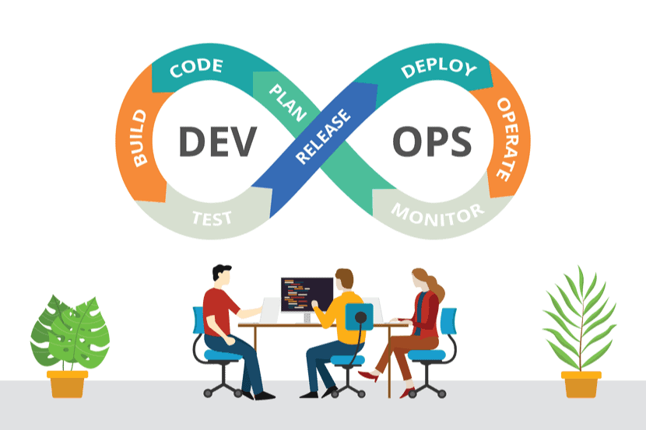

*GithubHub Link: Shivrajganacharya/bidding_app_frontend Guided By :*

*Shivrajganacharya/bidding_app_backen Prof. B. Thangaraju*

*Shubham Aggrawal*

*DockerHub:* shabbir148/b*idding_app_frontend*

shabbir148/b*idding_app_backend*

**Introduction About Project**



***Logo***

Bidding application for loading and unloading which we give name ShifThat. This is a web application where people can put advertisements about items that they want to shift. Transport people will make bids for those items. And the lowest bidder will get the deal. This application creates a win-win situation for both service provider and customer. Following features are implemented in this project :

1. User registration
2. User sign up
3. Publishing the advertisement
4. Transport person can make bid
5. User can view published advertisement
6. Transport person can see his bids
7. Bid result is calculated automatically bases on time

**ShipThat Application Work Flow and it’s Architecture**

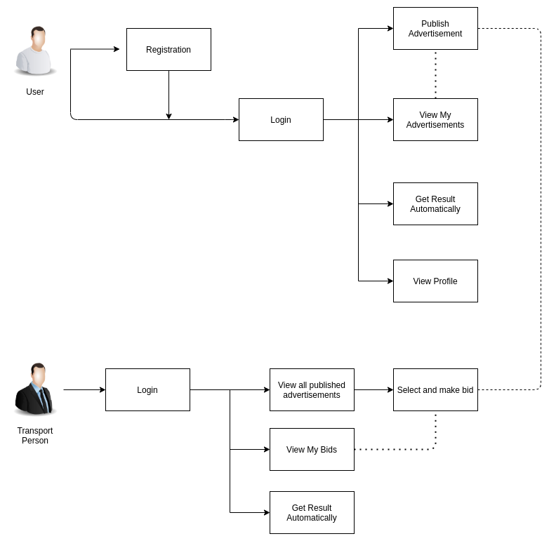

**DevOps Pipeline**

DevOps is an approach to culture, automation, and platform design intended to deliver increased business value and responsiveness through rapid, high-quality service delivery.

DevOps is approch in which we automate the integration and deployment. In the cycle includes pushing latest changes to git (GitHub), building code includes using tool (maven), pushing build docker image on to docker hub, this part of continuous automation is called continuous integration. Then for Continoues deployment integrate Jenkines with Ansible, ansible here does the continous automation is called continous deployment. Ansible pull images from Docker hub and deploys it on a server.

Tools used includes

* SCM-GitHub
* Intellij (Project IDE)
* Visual studio code (Project IDE)
* Building-maven
* Docker images
* Continuous Integration-jenkins
* Continuous deplotment – Ansible
* ELK (Elastic Search ,Logstash , kibana)

**1.Software Development life cycle**

The project is developed by the DevOps methology and using various tools. The software development Life Cycle of this project includes six stages

1. Source Control Management (Git)
2. Code Testing (Junit)
3. Code Building (Maven)
4. Continuous Integration
5. Containerization
6. Deployment
7. Monitoring

**1. Using of Git and GitHub for Version Control :**

Git is a distributed version-control system for tracking changes in source code during software development. It is designed for coordinating work among programmers, but it can be used to track changes in any set of files.

Using GitHub, we can create both public and private repositories. It also provides various features like fork, pull requests and issues, which are very often used in Open Source contribution.

The following Commands:

* git init
* git add .
* git commit -m “first commit”
* git remote add origin <https://github.com/shivrajganacharya/bidding_app_backend.git>
* git remote add origin <https://github.com/shivrajganacharya/bidding>_app_frontend.git
* git push -u orign master

Some git code from branching:

* git checkout -b “new_feature”
* git branch
* git push –set-upstream origin new_feature

By using this we create git repository and push our code on this, name of that repository is “bidding_app_backend” and “bidding_app_frontend” and than we did branching and push all over code in separate branch by this collobrate our work and after making any change we puch our code in jenkines pipeline which we discuss in nect section.

**Creating repositories:**

BACKEND:

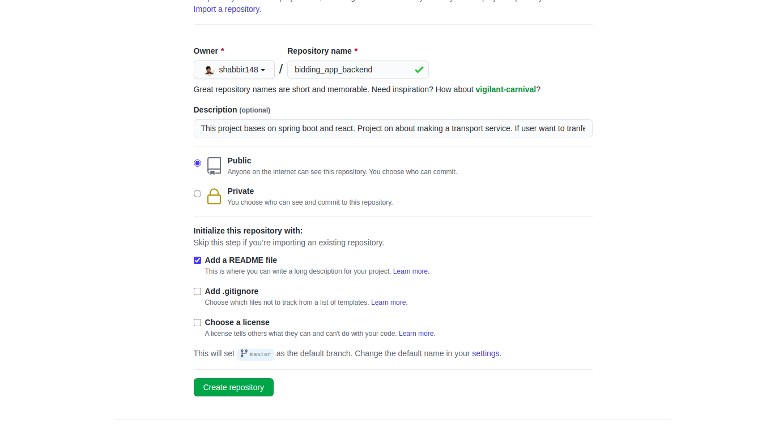

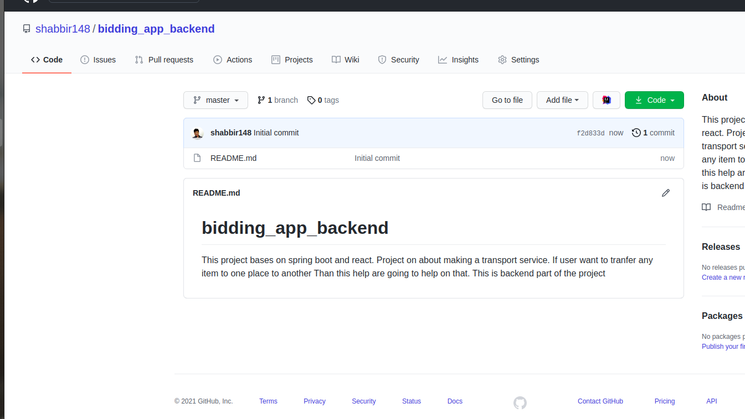**FOR FRONTEND REPOSITORY CREAT**

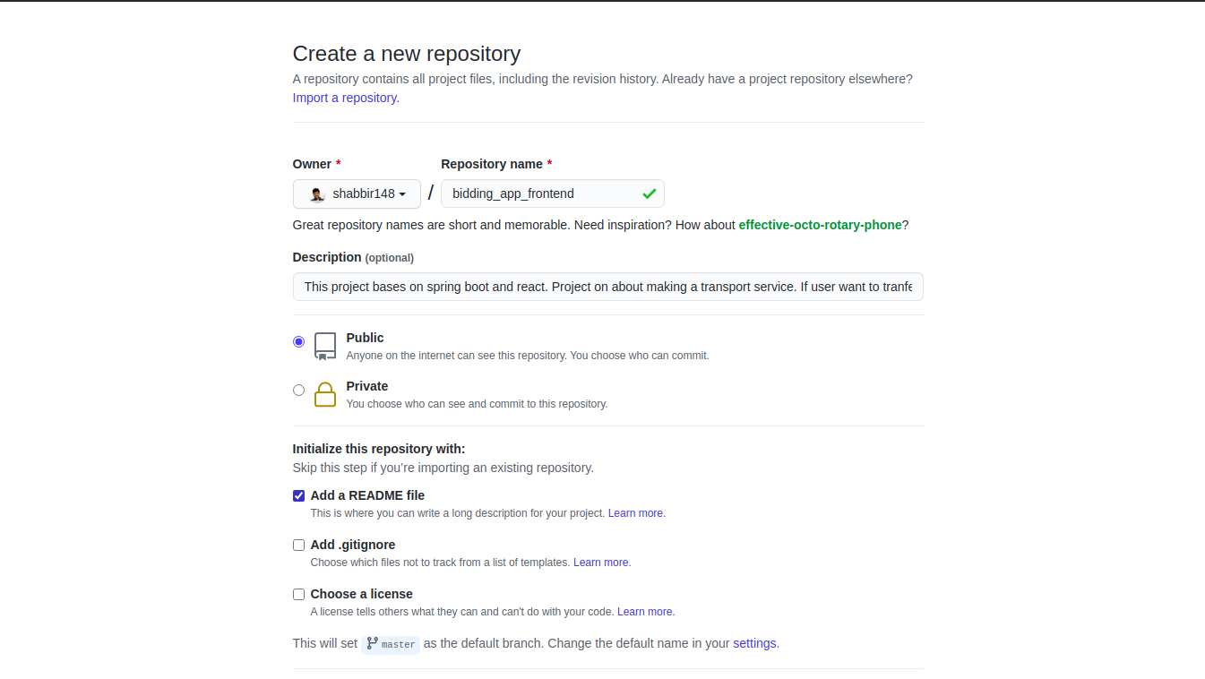

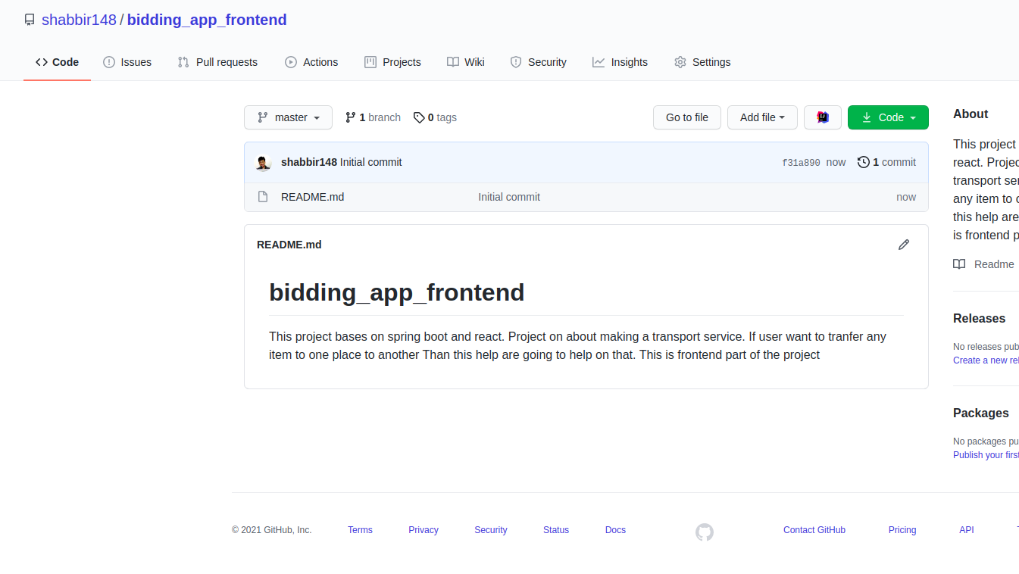

**git terminal** : pushed my source code to git by attaching remote repo to local repositories

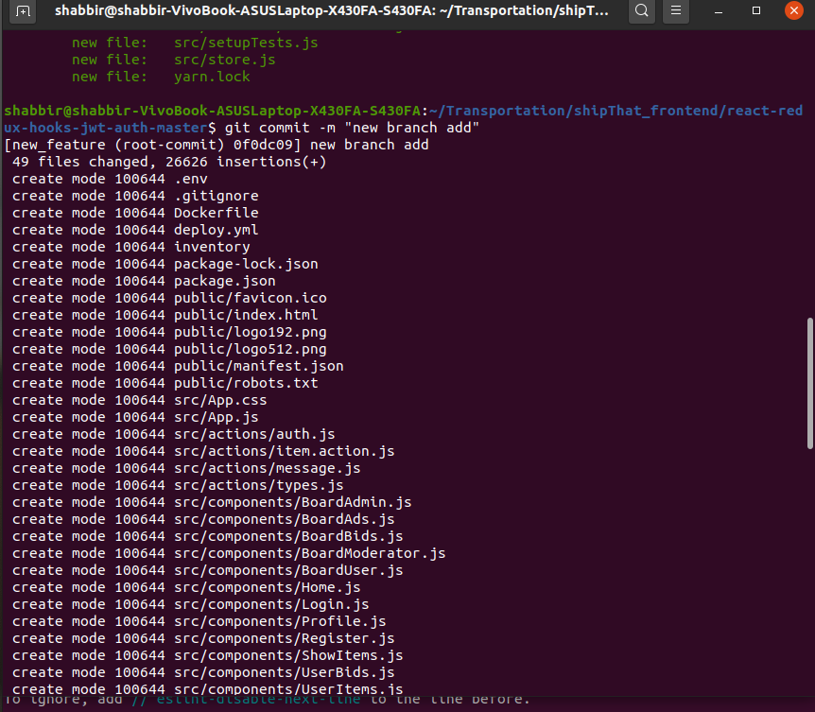

Diffrent commit done in git:

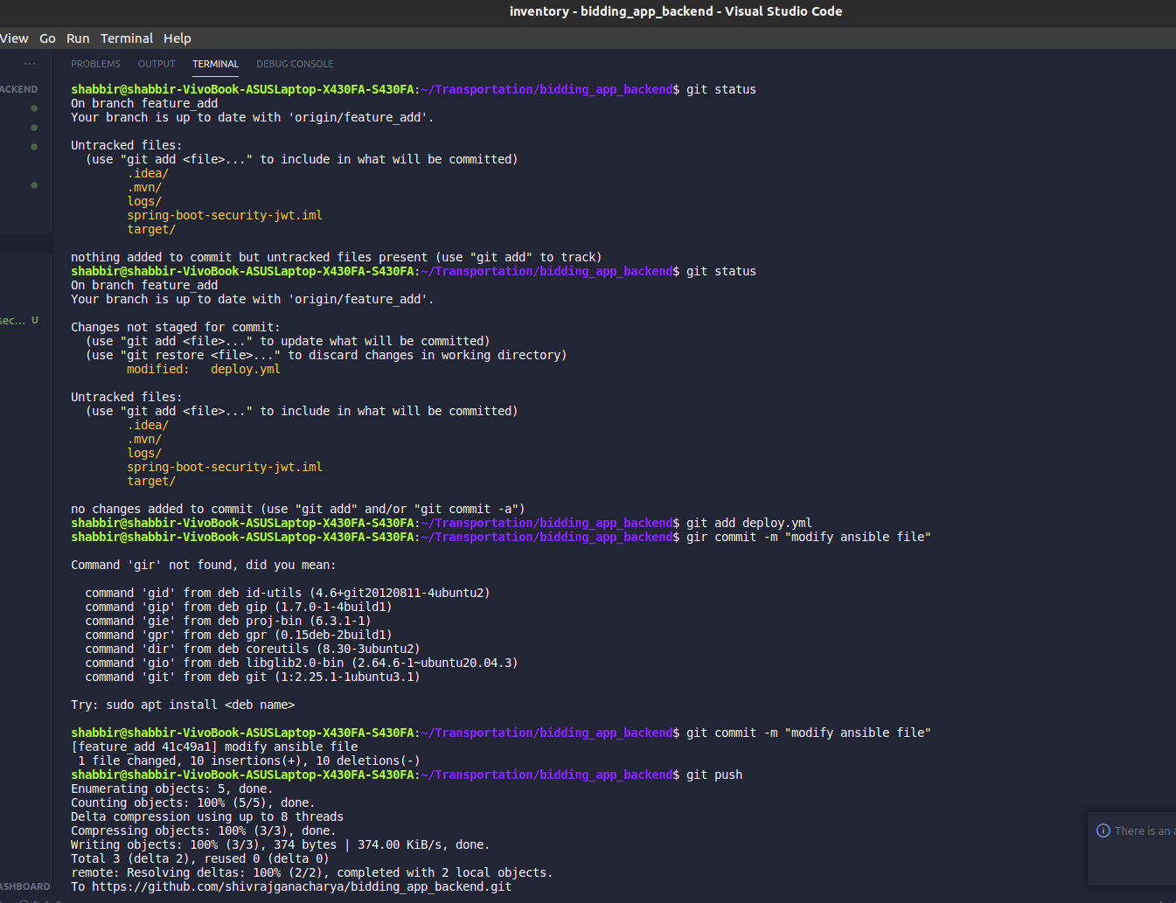

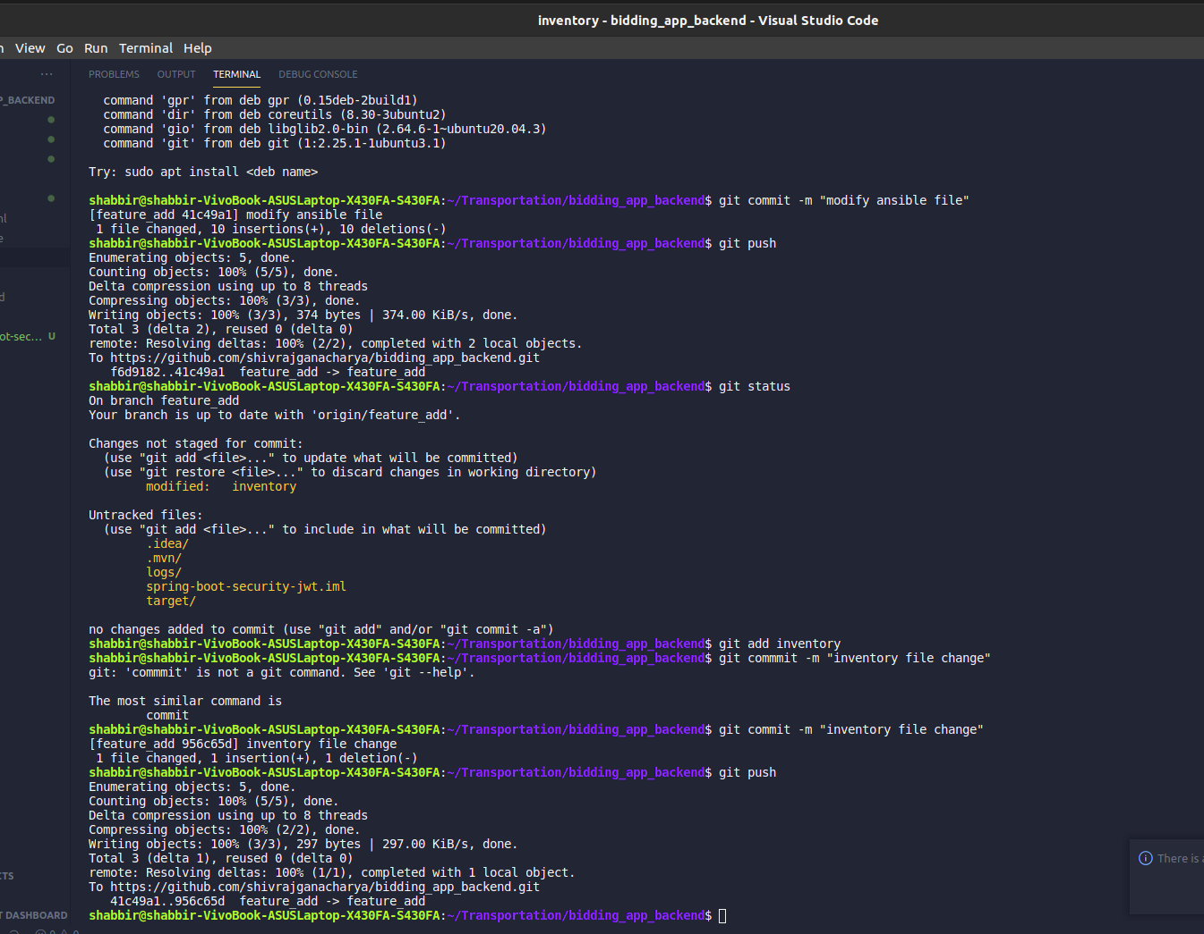

CREATING BRANCH:

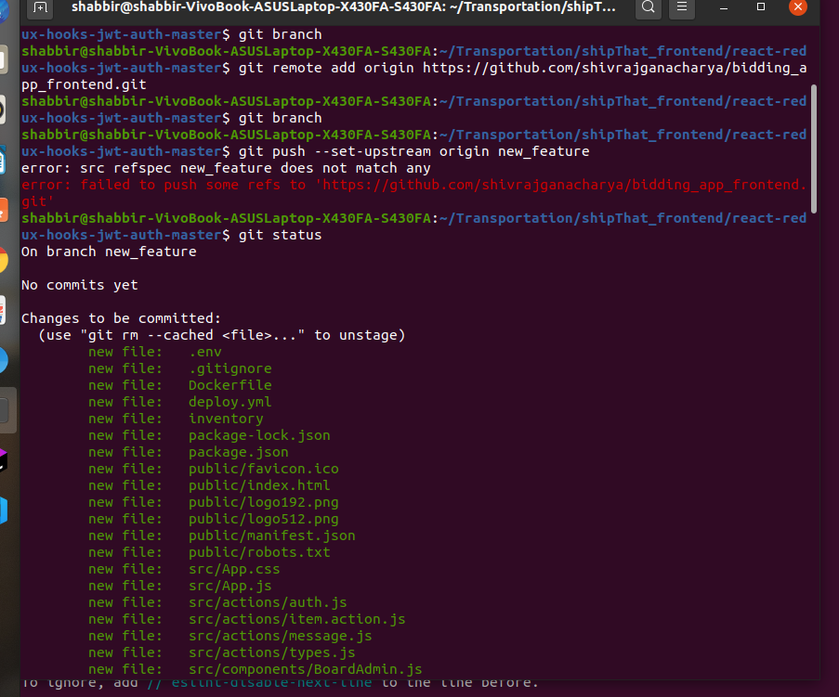



**2. Code Testing**

Spring Test and Spring Boot features to test the interactions between Spring and your code. You will start with a simple test that the application context loads successfully and continue on to test only the web layer by using Spring’s MockMvc.

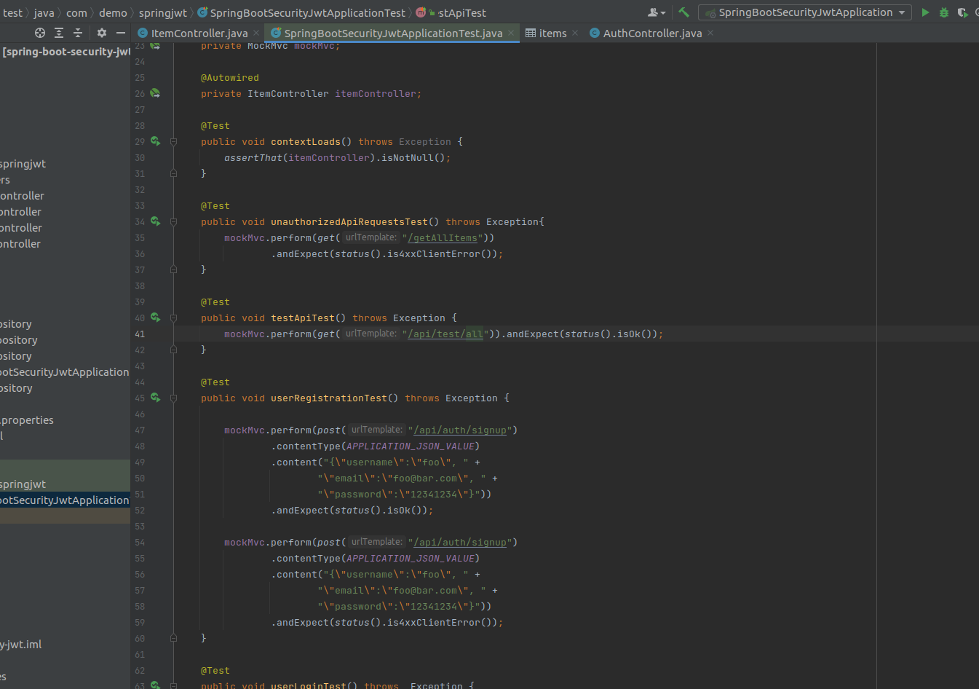

**3. Code Building (Maven) :**

# Maven is a powerful project management tool that is based on POM (project object model). It is used for projects build, dependency and documentation.

# In short terms we can tell maven is a tool that can be used for building and managing any Java-based project. maven make the day-to-day work of Java developers easier and generally help with the comprehension of any Java-based project.

# Maven is based around the central concept of a build lifecycle. There are three built-in build lifecycles: default, clean and site. The default lifecycle handles your project deployment, the clean lifecycle handles project cleaning, while the site lifecycle handles the creation of your project's site documentation.

Maven does a lot of helpful task like

StringBoot start in Maven:

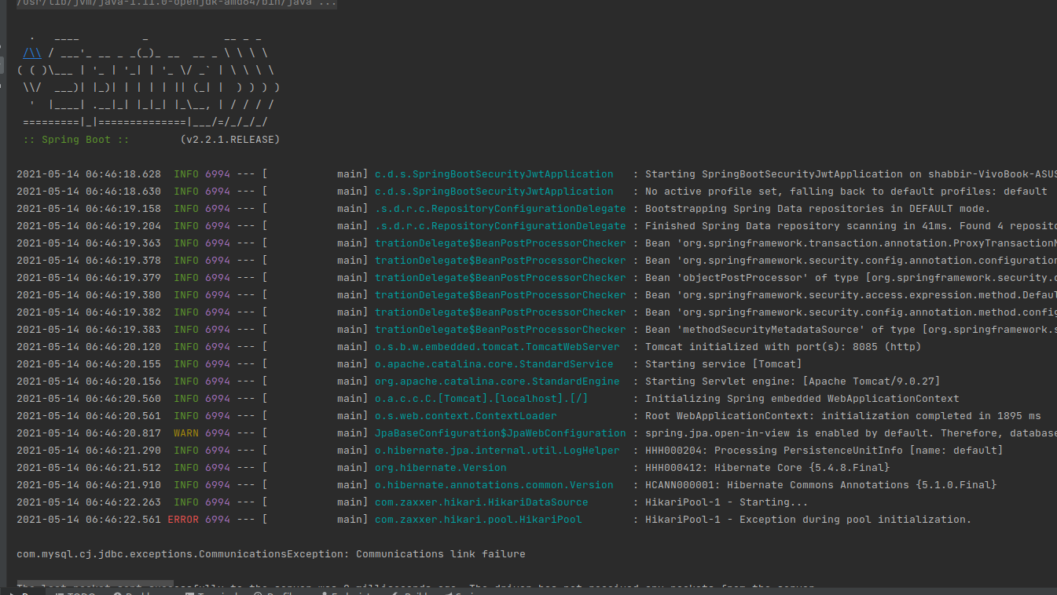

1. We can easily build a project using maven.
2. We can add jars and other dependencies of the project easily using the help of maven.
3. Maven provides project information (log document, dependency list, unit test reports etc.)
4. Maven is very helpful for a project while updating central repository of JARs and other dependencies.
5. With the help of Maven we can build any number of projects into output types like the JAR, WAR etc without doing any scripting.
6. 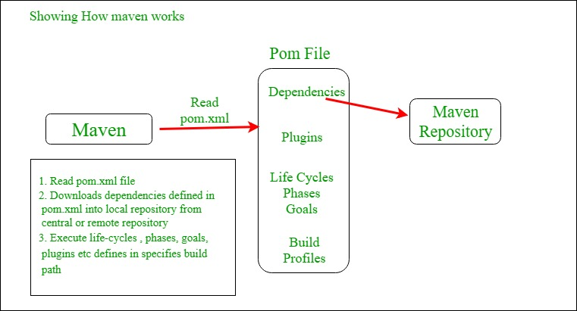Using maven we can easily integrate our project with source control system (such as Subversion or Git).

# **MVN COMMADS:**

# Mvn --version

# Mvn package

# Mvn test

# Mvn build

# Mvn clean

# Mvn install etc.

# Pom.xml file :

# POM is an acronym for Project Object Model. The pom.xml file contains information of project and configuration information for the maven to build the project such as dependencies, build directory, source directory, test source directory, plugin, goals etc.

Pom.xml file screenshot:

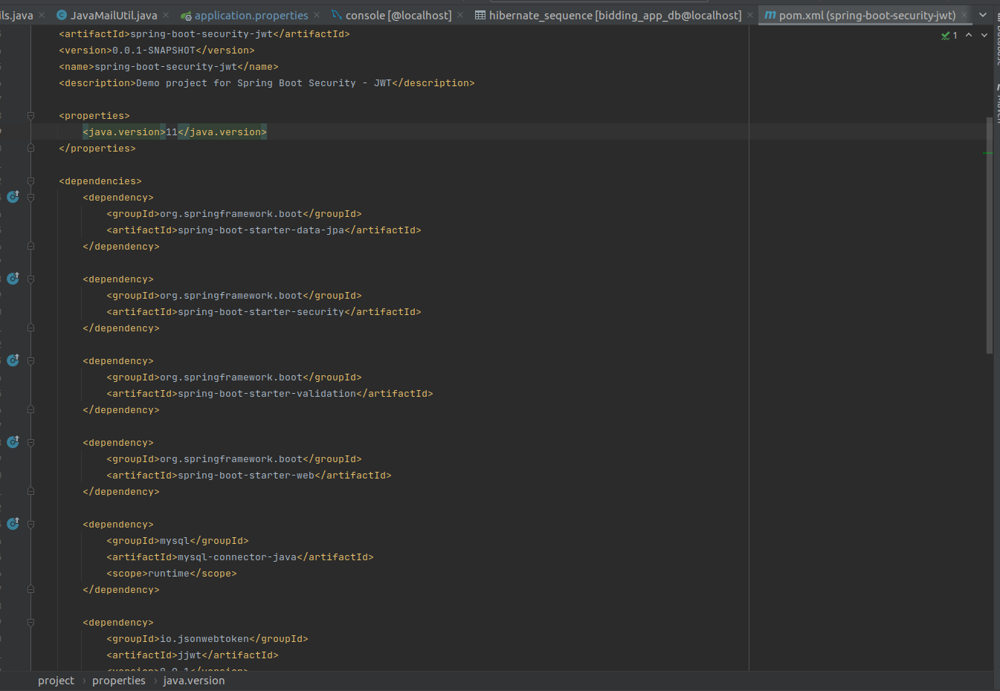

Mvn clean or mvn install command screenshot:

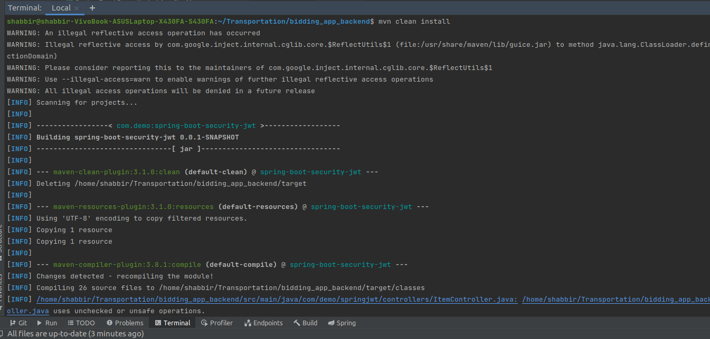

**4. Continuous Integration**

Continuous integration (CI) is the practice of automating the integration of code changes from multiple contributors into a single software project. It’s a primary [DevOps best practice](https://www.atlassian.com/devops/what-is-devops/devops-best-practices), allowing developers to frequently merge code changes into a central repository where builds and tests then run. Automated tools are used to assert the new code’s correctness before integration.

**A) Environment setup – Jenkins :**

Jenkins is a free and open source automation server. It helps automate the parts of software development related to building, testing, and deploying, facilitating continuous integration and continuous delivery.

Make sure to add Jenkins to docker group, so that Jenkins can use docker for build docker image. sudo usermod –aG docker Jenkins, you can verify it with sudo grep jenkins /etc/gshadow We can now start Jenkins with, by command sudo systemctl start jenkins, jenkins starts at port number 8080, so login on to http://localhost:8080 onto your browser.

Now we manage the plugins of jenkins under manage plugins in manage jenkins. We download Build pipeline plugin, Docker plugin, GitHub, Maven integration plugin, Ansible plugin.

This commad i was used:

* sudo apt-get update
* sudo apt install open-11-jre
* sudo apt-get install jenkines
* sudo system start jenkins
* sudo sysctl status jenkins ( to check status )

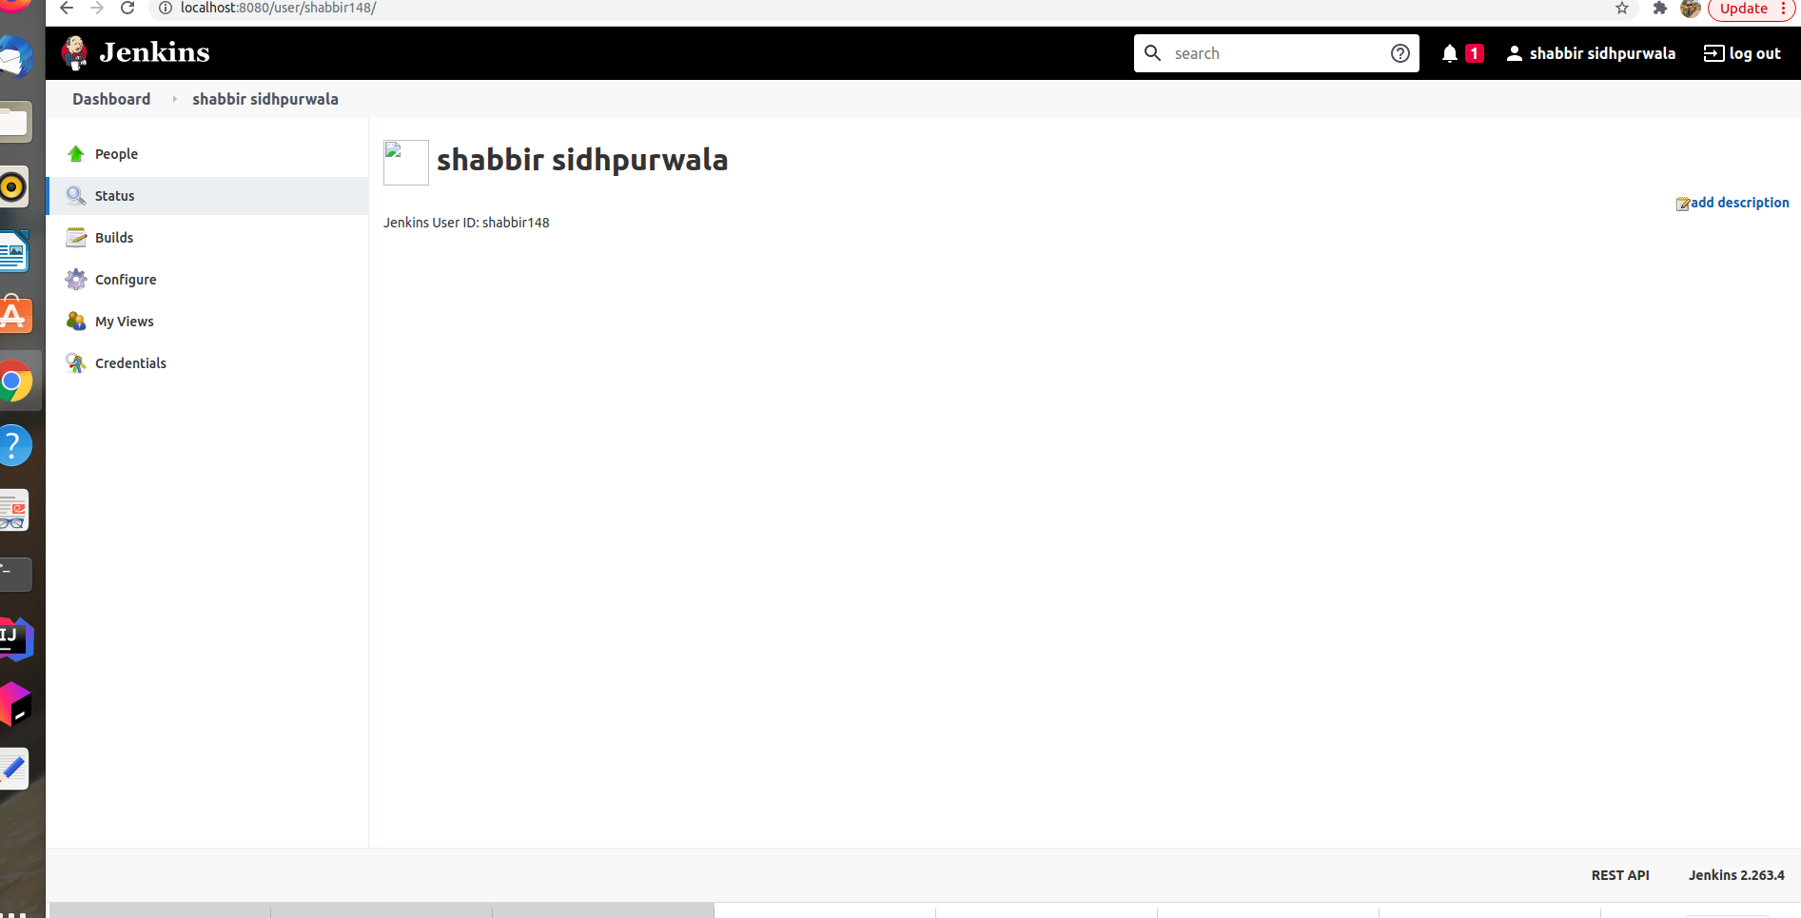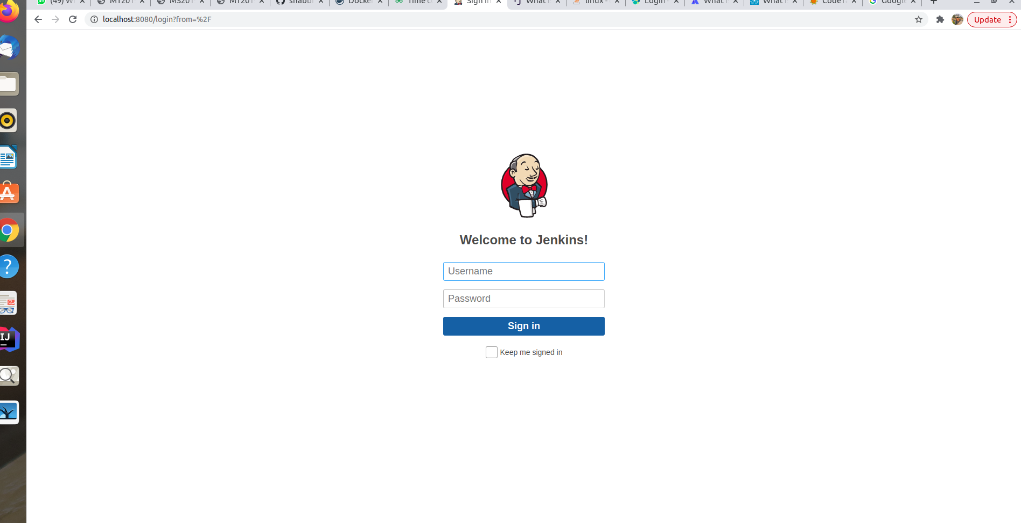

**B) Jenkins Setup :**

1. We can now start Jenkins with, by command sudo systemctl start jenkins, jenkins starts at port number 8080, so login on to http://localhost:8080 onto your browser

2. It will ask for initialAdminPassword and also provide the path where this password is saved. ~$ sudo cat /var/lib/jenkins/secrets/initialAdminPassword

3. Install General Plugins.

4. create a new user and Finish. Start using Jenkins.

5.**-->to add plugins**

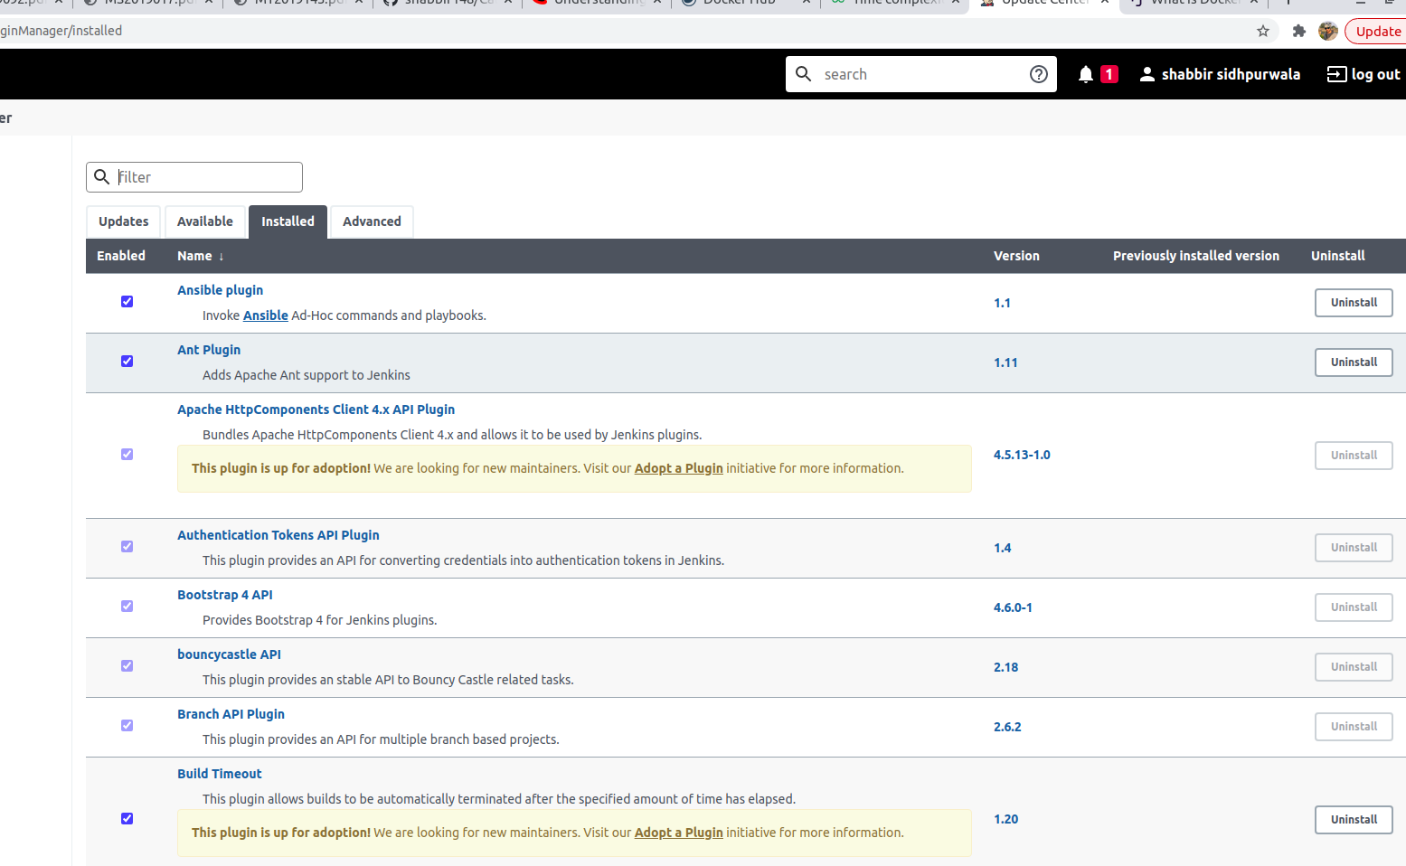

Manage Jenkins -> Manage Plugins -> Advanced -> Upload HPI file -> Install without restart

1. Git

2. GitHub plugin

3. Unleash Maven plugin

4. Docker plugin

5. Pipeline

6. Ansible

6. Manage Jenkins -> Configure System (Here I am specifying the things that needs to be changed. Rest all leave to default)

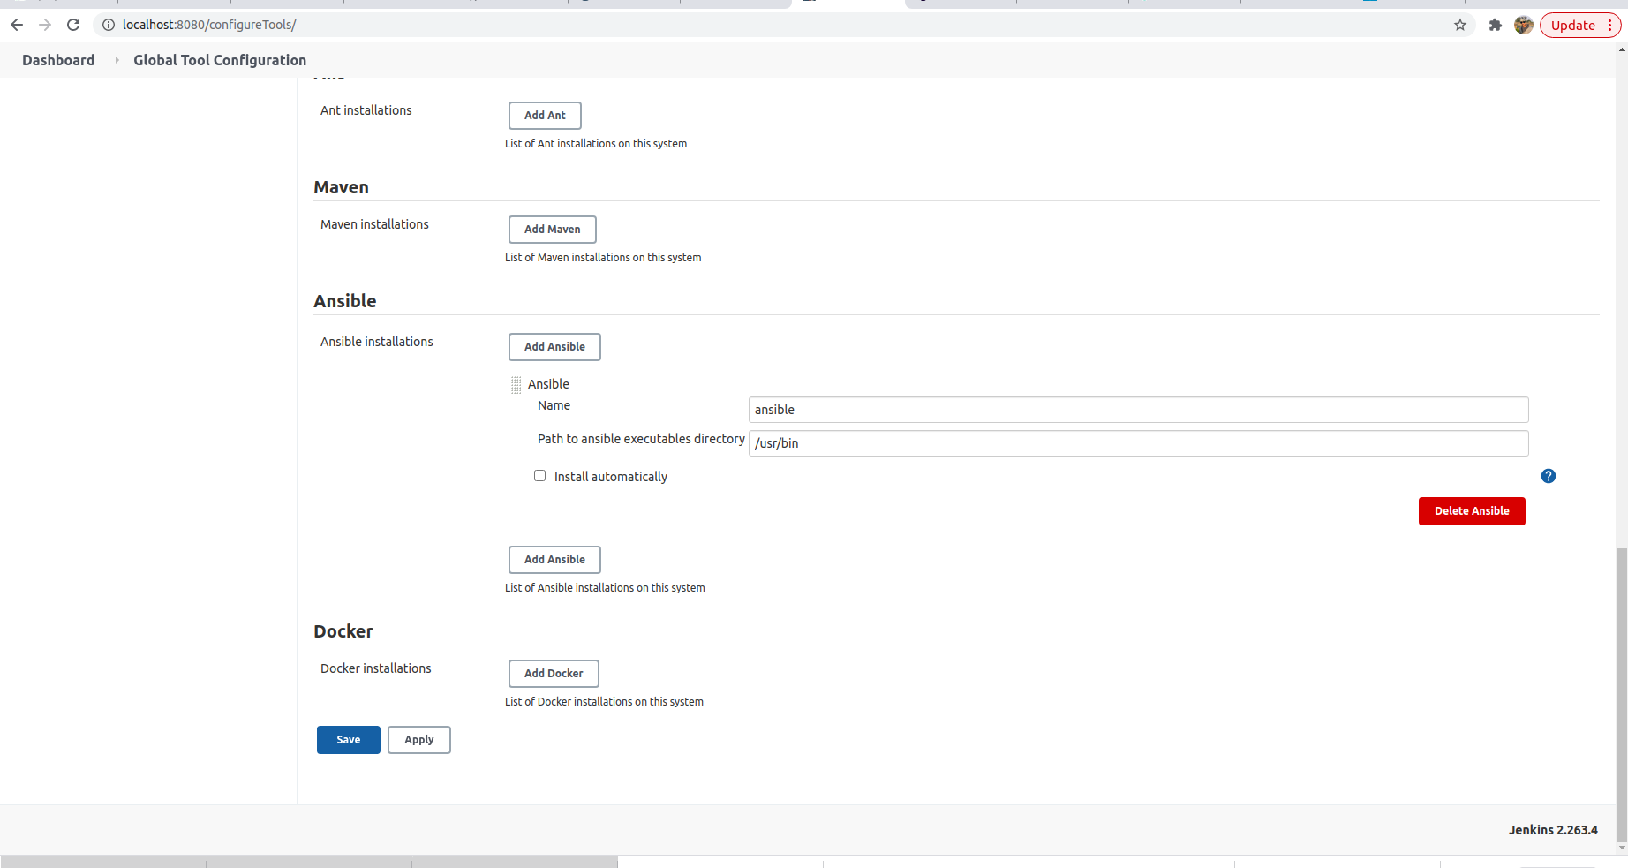

**C. Building jenkins pipeline**

Jenkins -> New Item -> Pipeline -> Enter item name -> Ok

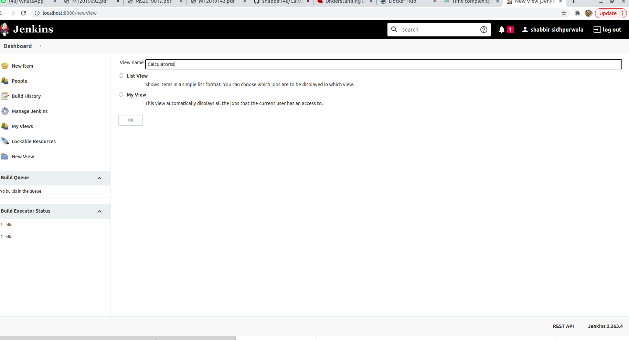

a) General section -> Fill the description

b) Build Periodically -> check GitHub hook trigger for GITScm polling

c) Pipeline: choose as script and following the code for my pipeline.

***PIPELINE SCRIPT :***

***pipeline {***

***environment {***

***registryCredential = 'docker-hub-credentials'***

***dockerImage = ''***

***}***

***agent any***

***stages {***

***stage('Clonaing our Git') {***

***steps {***

***git branch: 'feature_add', url: 'https://github.com/shivrajganacharya/bidding_app_backend.git'***

***}***

***}***

***stage('Maven Build'){***

***steps{***

***sh 'mvn clean install'***

***}***

***}***

***stage('Building our image') {***

***steps {***

***script {***

***dockerImage = docker.build 'shabbir148/bidding_app_backend:latest'***

***}***

***}***

***}***

***stage('Deploy our image') {***

***steps {***

***script {***

***docker.withRegistry( '', registryCredential ) {***

***dockerImage.push()***

***}***

***}***

***}***

***}***

***stage('Deploy with ansible') {***

***steps {***

***ansiblePlaybook becomeUser: null, colorized: true, disableHostKeyChecking: true, installation: 'Ansible', inventory: 'inventory', playbook: 'deploy.yml', sudoUser: null***

***}***

***}***

***stage('Cloning our Git Frontend') {***

***steps {***

***git branch: 'new_feature', url: 'https://github.com/shivrajganacharya/bidding_app_frontend.git'***

***}***

***}***

***stage('Building our image Frontend') {***

***steps {***

***script {***

***dockerImage = docker.build 'shabbir148/bidding_app_frontend:latest'***

***}***

***}***

***}***

***stage('Deploy our image Frontend') {***

***steps {***

***script {***

***docker.withRegistry( '', registryCredential ) {***

***dockerImage.push()***

***}***

***}***

***}***

***}***

***stage('Deploy with ansible Frontend') {***

***steps {***

***ansiblePlaybook becomeUser: null, colorized: true, disableHostKeyChecking: true, installation: 'Ansible', inventory: 'inventory', playbook: 'deploy.yml', sudoUser: null***

***}***

***}***

***}***

***}***

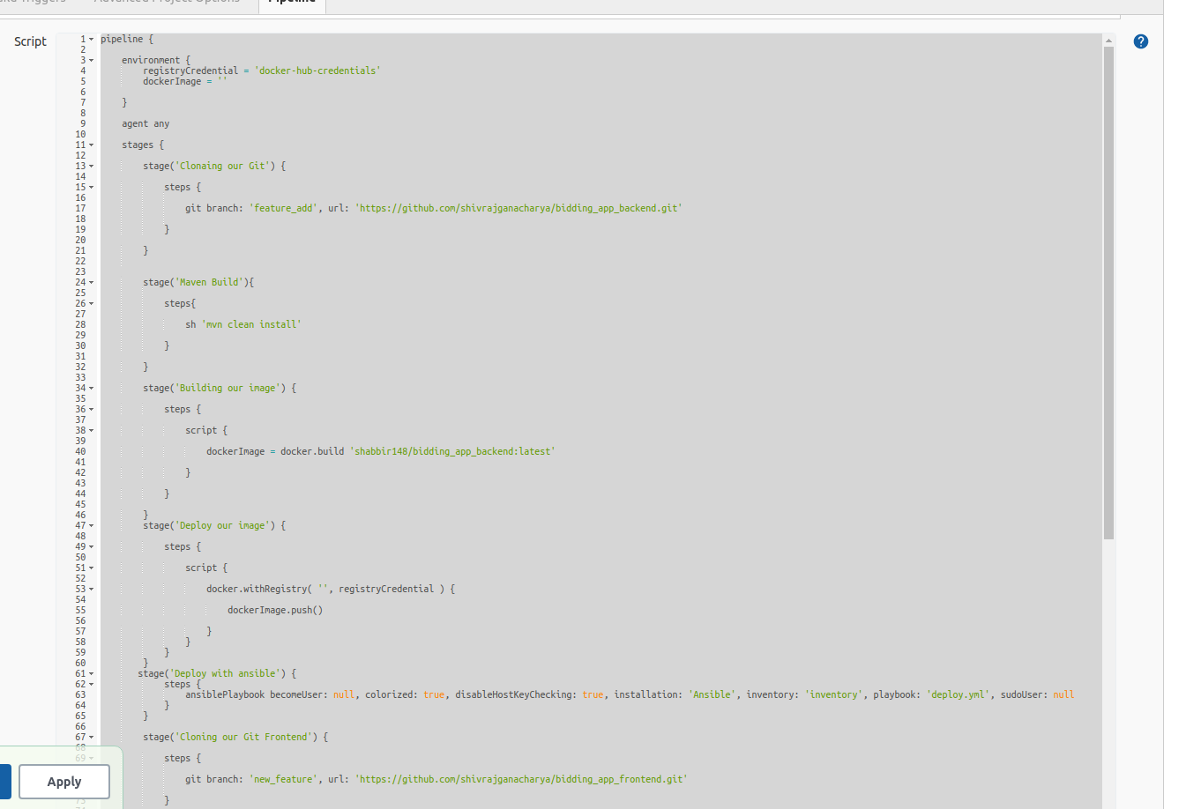

**By jenkines we use continous delivery and continous deplotment:**

whenever we make enhancment or any feauture update in our project we run jenkines pipeline for apply that changes in our working project and deploy it in server bu the help of ansible playbook. So by this we acheived continous delivery and deplotment for our application.

Here the screenshot of pipeline which show jenkines pipeline run whenever any feature upadate and any bugs fixed.

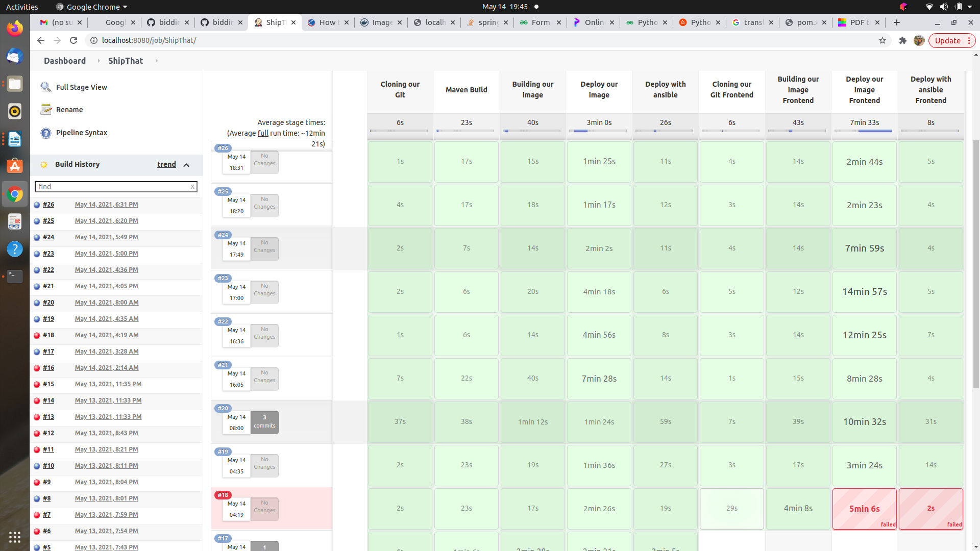

**5. Containerization**

**Intalling Docker :**

Docker is a tool designed to make it easier to create, deploy, and run applications by using containers. Containers allow a developer to package up an application with all of the parts it needs, such as libraries and other dependencies, and ship it all out as one package.

**Docker container** is an open source software development platform. Its main benefit is to package applications in “**containers**,” allowing them to be portable among any system running the Linux operating system (OS).

**Docker Hub** is a cloud-based registry service which allows you to link to code repositories, build your images and test them, stores manually pushed images, and links 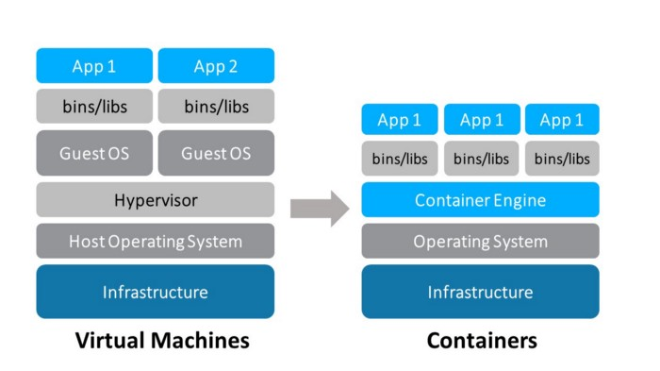to **Docker** Cloud so you can deploy images to your hosts.

**The following commands:**

* sudo apt update
* sudo apt install docker.io

**Other docker specific commad which i learn using docker**

$ docker images – List all the docker images

$ docker create ubuntu (create container for ubuntu images)

$ docker create --name test ubuntu

$ docker create -i-t –name user 1 ubuntu (i- interactive, t-terminal,name-give your name to ubuntu container)

$ docker start user 1

$ docker stop user 1

$ docker attach user 1

$ docker cp user.txt user 1:user.txt

$ docker cp user 1:user.txt /home/raju/user.txt (copy commad)

$ docker ps -a -q (– list all existing containers)

$ docker rmi <image name> - remove given docker image

$ docker stats

$ docker logs user 1

$ docker logs -f user 1

**Docker linkage with jenkins**

$ sudo usermod -a -G docker jenkins

$ sudo chmod 777 /var/run/docker.sock

***Commands*:**

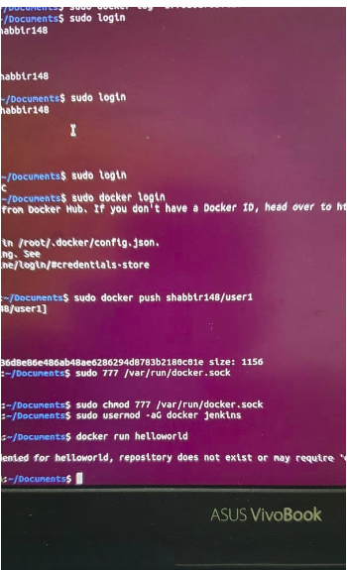

***Docker hub repositories:***

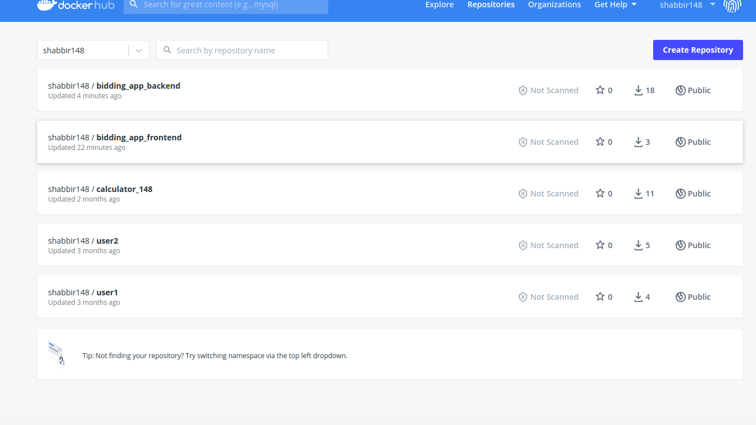

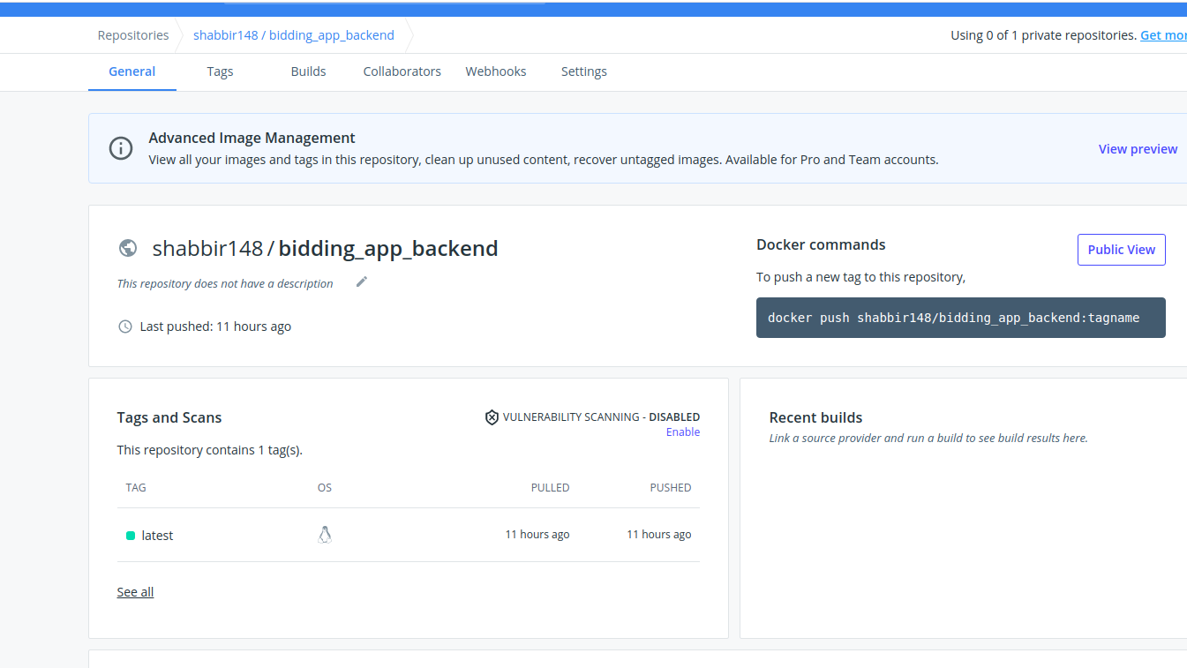

***Docker file***

***For Frontend:***

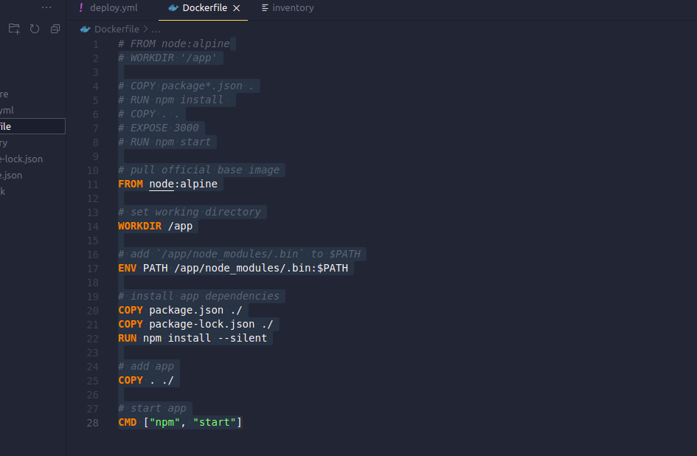***For Backend:***

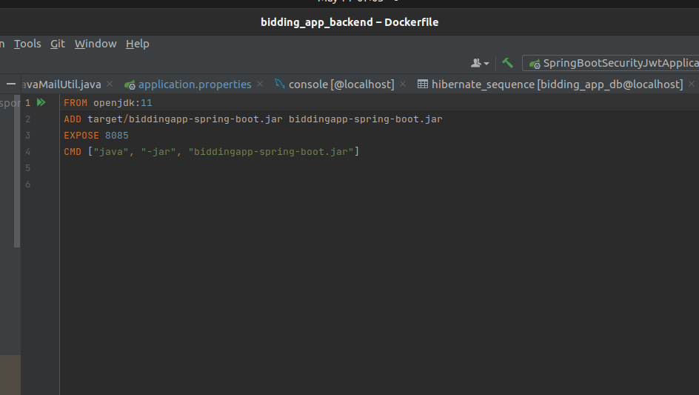

***6. Deployment of the project:***

Continuous deployment is a strategy for Software releases wherein any code commit that passes the automated testing phase is automatically released into the production environment, making changes that are visible to the software's users.

**USE ABSIBLE FOR CONTINOUS DEPLOYMENT :**

Ansible is a software tool that provides simple but powerful automation for cross-platform computer support. It is primarily intended for IT professionals, who use it for application deployment, updates on workstations and servers, cloud provisioning, configuration management, intra-service orchestration, and nearly anything a systems administrator does on a weekly or daily basis. Ansible doesn't depend on agent software and has no additional security infrastructure, so it's easy to deploy.

**Installing Ansible**

Ansible is simple to install. The Ansible software only needs to be installed on the control node (or nodes) from which Ansible will be run. Hosts that are managed by Ansible do not need to have Ansible installed. This installation involves relatively few steps and has minimal requirements. The control node should be a Linux or UNIX system. Microsoft Windows is not supported as a control node, although Windows systems can be managed hosts.

There’s various parts in Ansible installation, Ansible in the backend uses python to run various small codes and uses ssh in linux to connect to the hosts machines.

For Ansible to work make sure you have python and ssh server installed on your controller

and managed nodes. Python is generally installed in most of the linux flavours. But if you are working on docker image this might help.

### Installing python3 on Ubuntu 18/20 follow the following link

h [ttps://phoenixnap.com/kb/how-to-install-python-3-ubuntu](https://phoenixnap.com/kb/how-to-install-python-3-ubuntu)

Let’s install the SSH server on your controller and to be managed hosts.

$ sudo apt install openssh-server

$ ssh-keygen -t rsa

Finally let’s install ansible, you ned to install ansible in only control node

$ sudo apt update

$ sudo apt install ansible

***Commands:***

$ sudo apt install openssh-server

$ ssh-keygen -t rsa

$ sudo apt update

$ sudo apt install ansible – install ansible over controller node

$ ansible –version

**- Run these commands in controller node :**

$ sudo su - jenkins

$ ssh-keygen -t rsa

$ ssh-copy-id [vivo@localhost](mailto:vivo@localhost)

***Ansible which are use in this project***

***Configration code or file:***

The behavior of an Ansible installation can be customized by modifying settings in the

Ansible configuration file. Ansible chooses its configuration file from one of several possible locations on the control node.

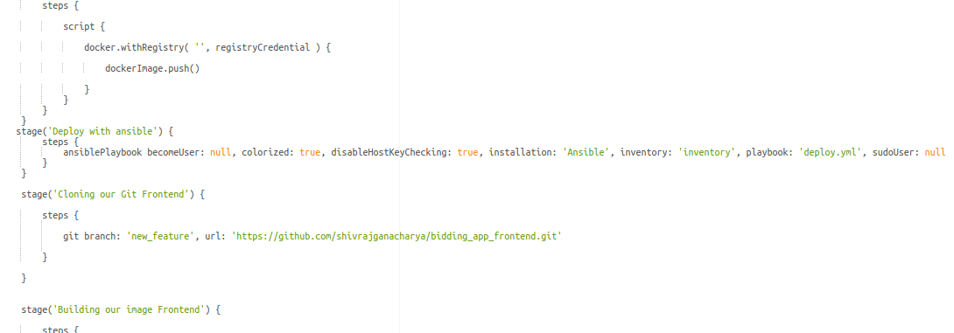

***Configration code:***

ansiblePlaybook becomeUser: null, colorized: true, disableHostKeyChecking: true, installation: 'Ansible', inventory: 'inventory', playbook: 'deploy.yml', sudoUser: null

***Playbook or yam file***

A play is an ordered set of tasks run against hosts selected from your inventory. A playbook is a text file containing a list of one or more plays to run in a specific order.

*A playbook is a text file written in YAML format, and is normally saved with the extension yml. The playbook uses indentation with space characters to indicate the structure of its data.*

***For Frontend:***

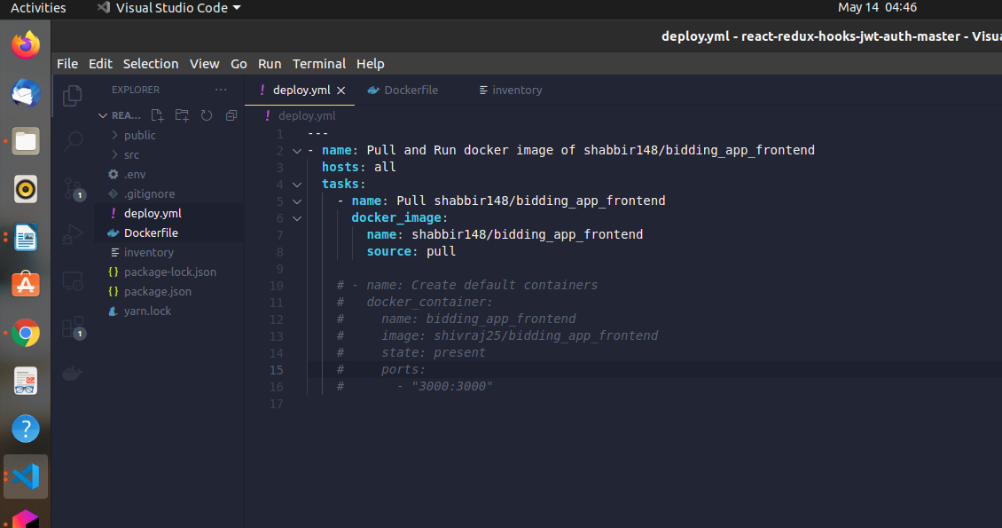

***For Backend:***

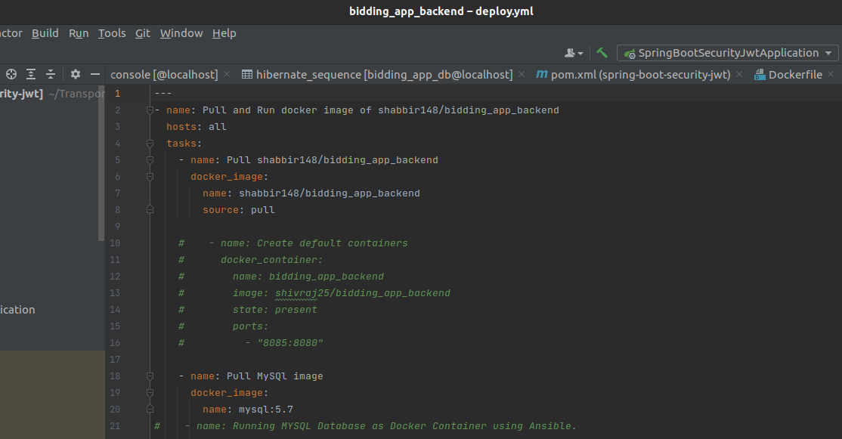***Inventory:***

An inventory defines a collection of hosts that Ansible will manage. These hosts can also be assigned to groups, which can be managed collectively. Groups can contain child groups, and hosts can be members of multiple groups.

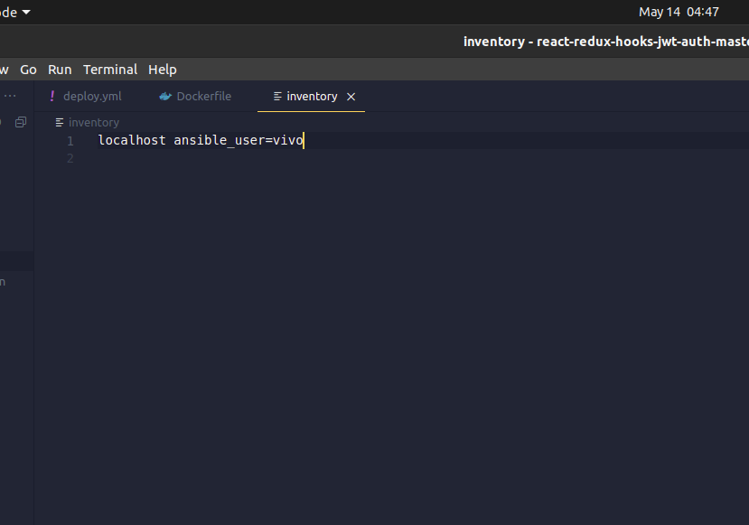

**7. Monitoring : Elastic Stack – Elastic Search, Logstash, Kibana**

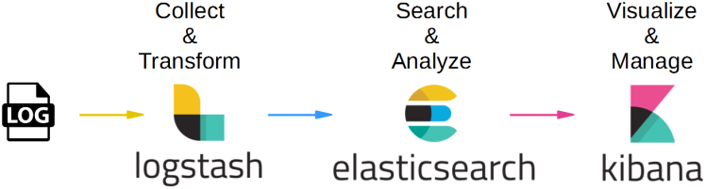

Elastic Stack is a group of products that can reliably and securely take data from any source, in any format, then search, analyze, and visualize it in real-time. Elasticsearch is a distributed, RESTful search and analytics engine that can address a huge number of use cases. Also considered as the heart of the Elastic Stack, it centrally stores user data for high-efficiency search, excellent relevancy, and powerful analytics that is highly scalable.

#### Core Products of Elastic Stack

The core products that define an Elastic stack are listed below:

* Elastic Search – Search and analytics engine.
* Logstash – Data processing pipeline.
* Kibana – Dashboard to visualize data.

To start with download elastic search, logstash and kibana from https://www.elastic.co Run them side by side and feed the logstash your log set after configuring it config file. In the config file we provide the details for logs. Here the config file logstash.conf Elastic search starts at localhost:9200, and kibana starts at localhost:5601.

Commands to run

* Elastic search - ./path_to_elastic_search/bin/elastic
* Logstash - ./path_to_logstash/bin/logstash –f ./path_to_logstash.conf
* Kibana - ./path_to_kibana/bin/kibana

But we didn’t use Elastic stack on our machine because we dont have that amount of memery so we used Elastic stack on clould.

**Screen shot of cloud id**

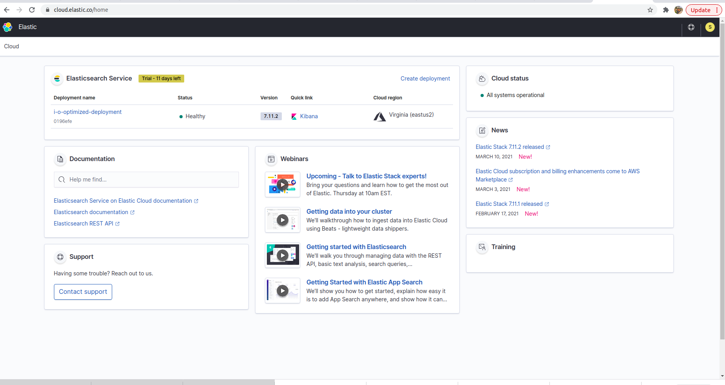

**Log configretion file : file name is “logback-spring.xml”**

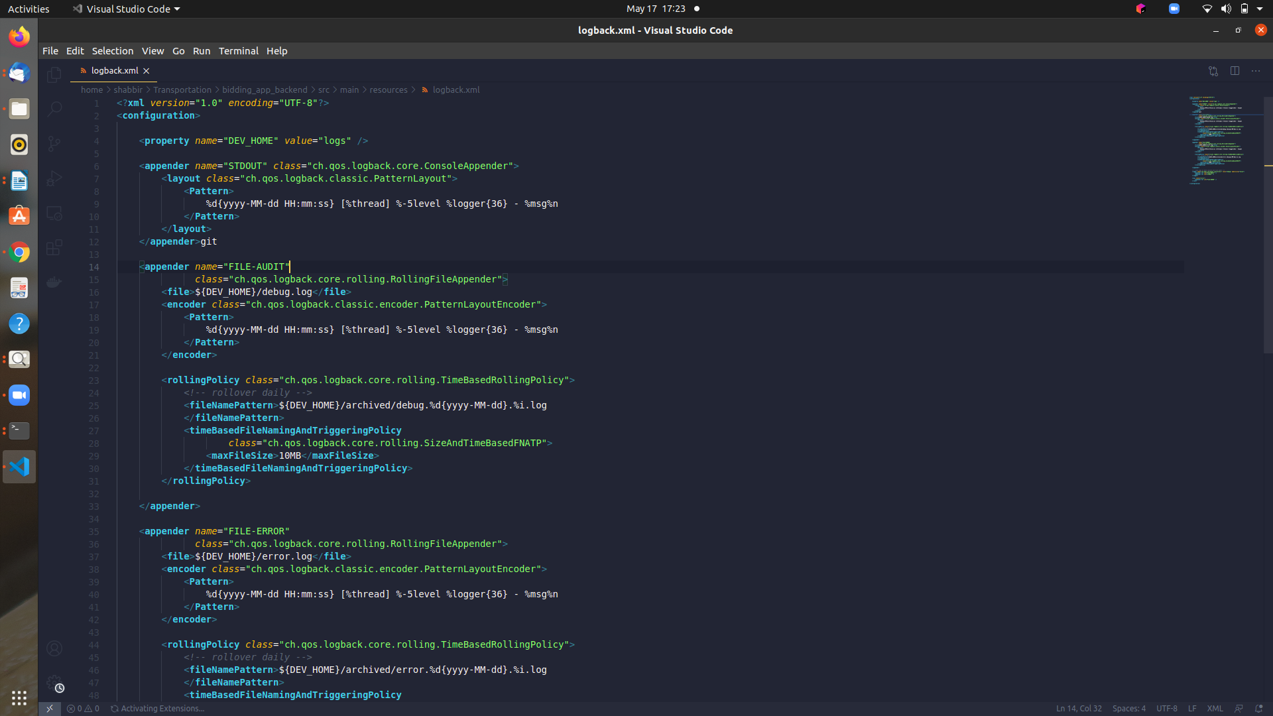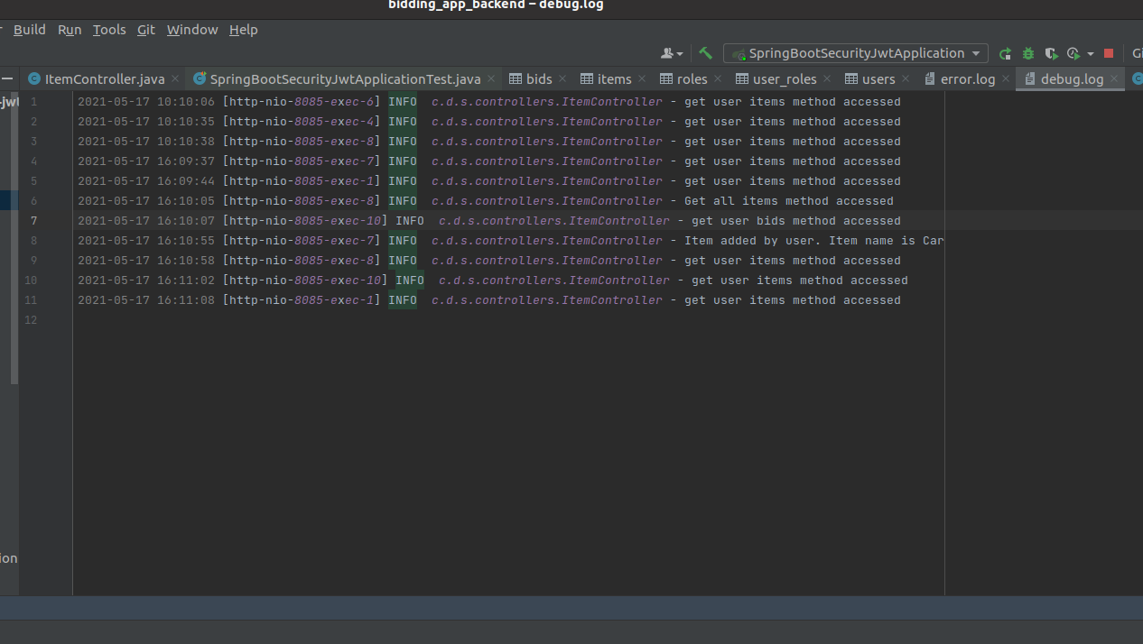**Sample Log File**: File name is “degug file”

**Kibana visualization:**

Kibanais a data visualization dashboard for Elasticsearch. It provides visualization capabilities on top of the content indexed on an Elasticsearch cluster. Users can create bar, line and scatter plots, or pie charts and maps on top of large volumes of data.

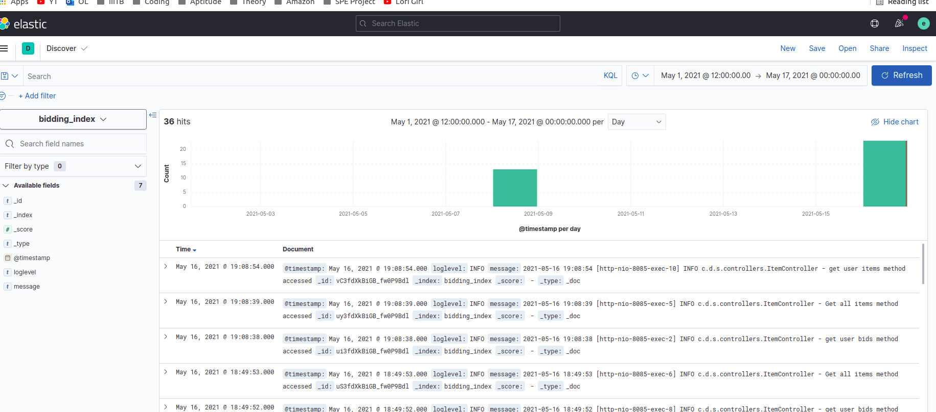

***8. Challenges and solution :***

we buil the project and check if there are any errors

we face many error and challenges when we builded:

**Build 1 :** First Error came in build face when i would build my project with maven and maven doesn’t found plugins or some error for depandency, so update my pom.xml file and re run my project

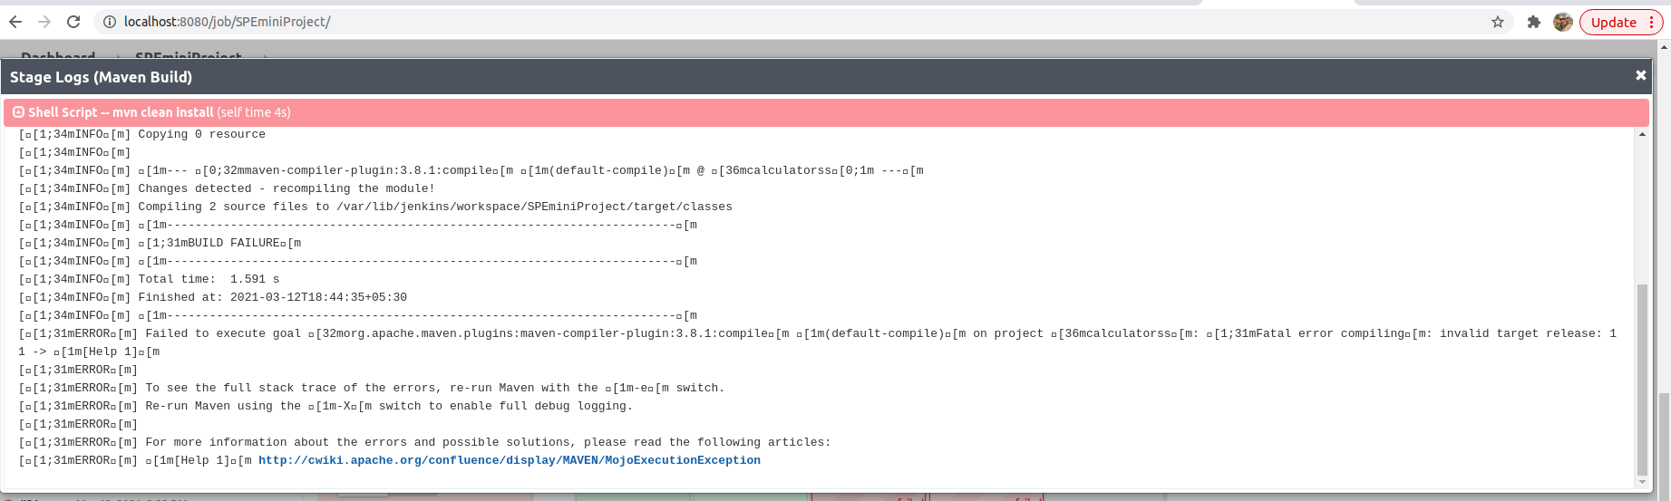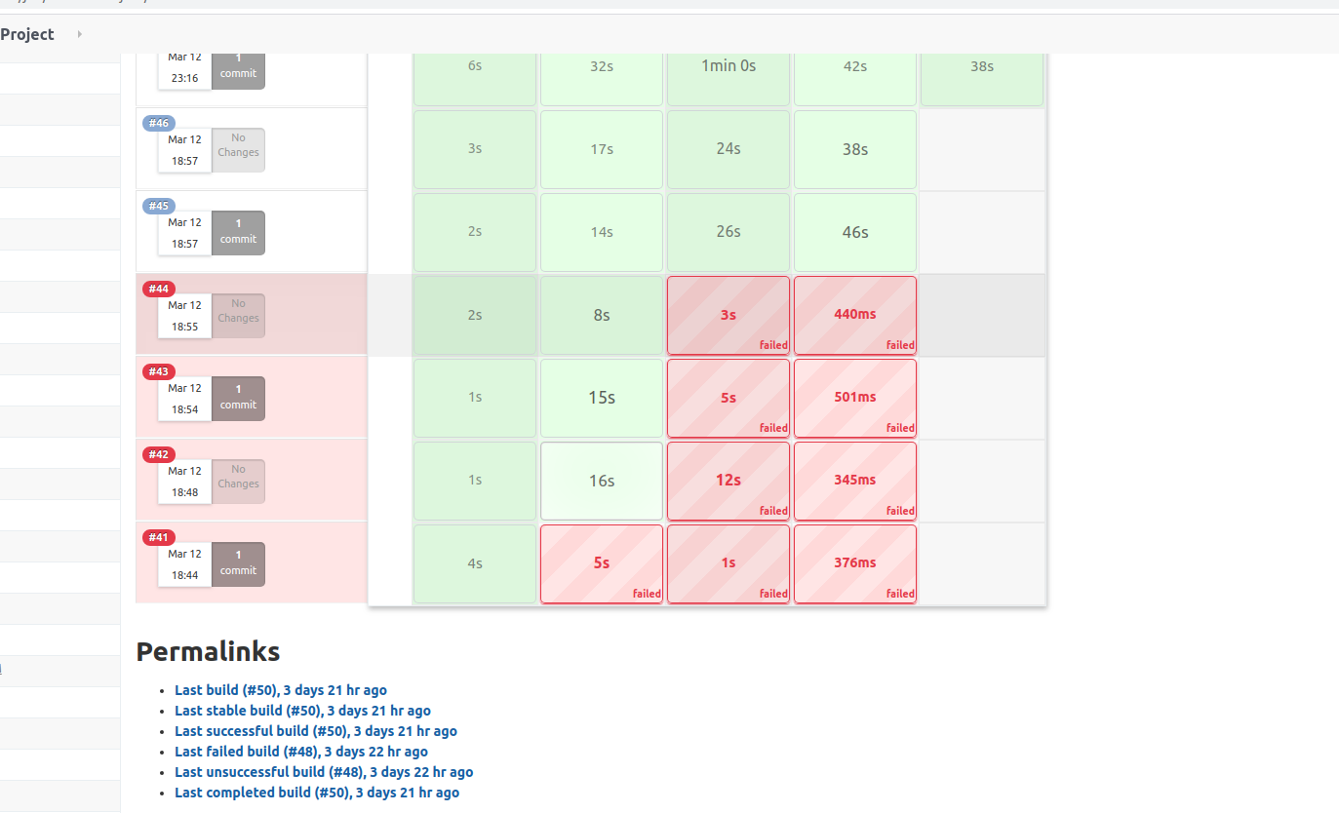

**pom push in git hub images :**



**Build 2 :** It failed because the permission was not given to the docker properly.

It was solved by following command :

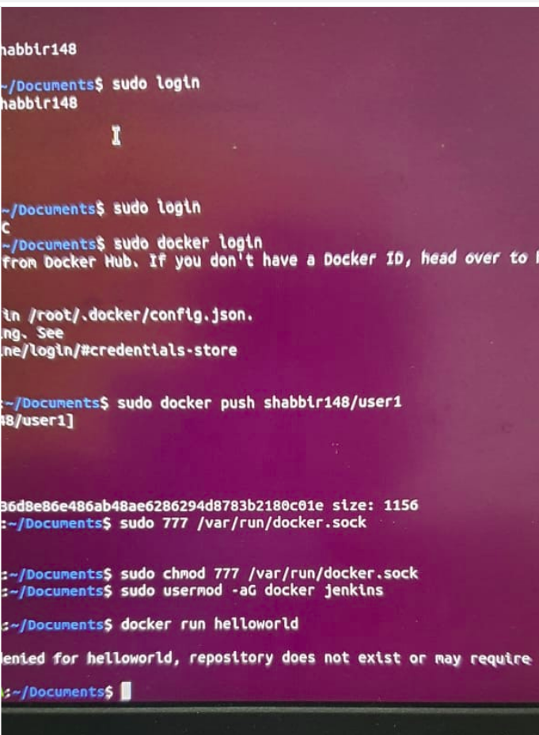● sudo chmod 777 /var/run/docker.sock

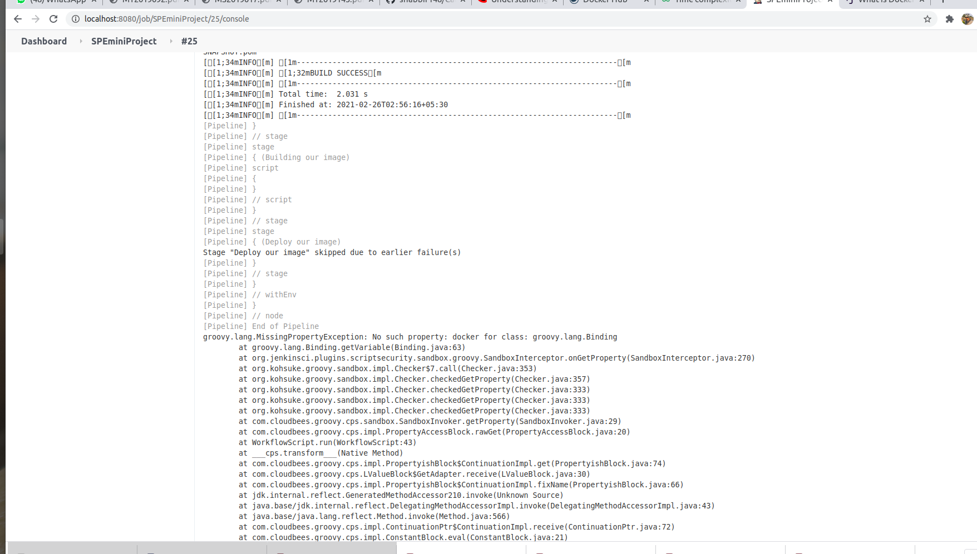

***Build 3 :*** Problem occured in same stage in previous build. This time problem is diffrent because my jenkins user doesn’t have docker permission which can be easily given via s**udo usermod –aG jenkins docker.**



So again make sure to add Jenkins to docker group, so that Jenkins can use docker for build docker image. **sudo usermod –aG docker Jenkins**, you can verify it with **sudo grep jenkins /etc/gshadow.** Don’t forget to restart jenkins job after that using sudo systemctl restart jenkins

**Build 4 : Ansible**

This is not exactly builded by jenkines, but i was building on my machine localy and i face issue in ansible becuase of python pip version but at the end i corrected by install right pip version.

You can verify the ansible_python_version on the controller node by using the setup module.

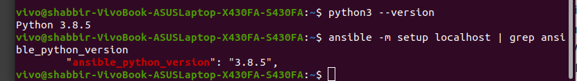

After when i tried to deploy my project on another user which was i create locally on my machine i found a errror port 22 are not respond. So this is another challenge which i solve by the help of stackover follow and this commad.

ssh -vvv localhost

OpenSSH_5.5p1, OpenSSL 1.0.0e-fips 6 Sep 2011

debug1: Reading configuration data /etc/ssh/ssh_config

debug1: Applying options for *

debug2: ssh_connect: needpriv 0

debug1: Connecting to localhost [127.0.0.1] port 22.

debug1: connect to address 127.0.0.1 port 22: Connection refused

ssh: connect to host localhost port 22: Connection refused

**Build 5 : Developed complete project by continuous integration and deployment**

Application was successfully Create and deployed in the user “vivo”.

Whenever we make enhancment or any feauture update in our project we run jenkines pipeline for apply that changes in our working project and deploy it in server bu the help of ansible playbook. So by this we acheived continous delivery and deplotment for our application.

Here the screenshot of pipeline which show jenkines pipeline run whenever any feature upadate and any bugs fixed.

**

**9. Working ShipThat :**

This project bases on spring boot and react. Project on about making a transport service. If user want to tranfer any item to one place to another Than this application or idea are going to help user for that item

* ***Home page with login:***

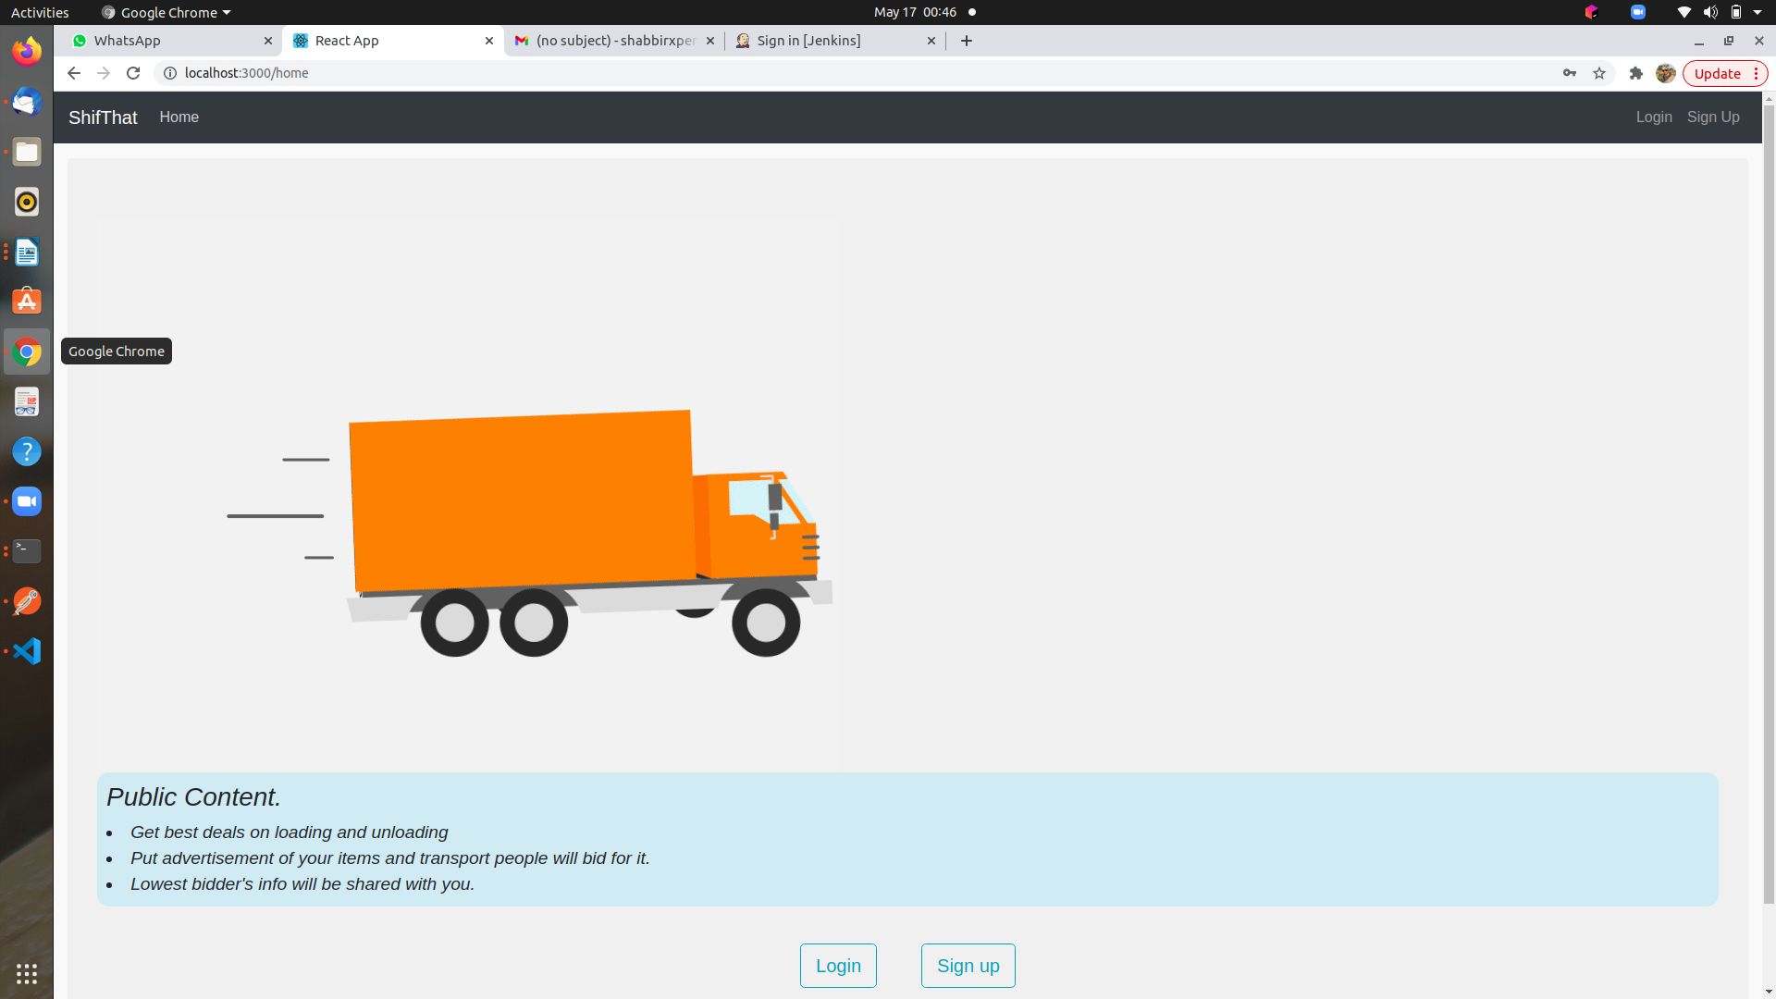

* ***Login page:***

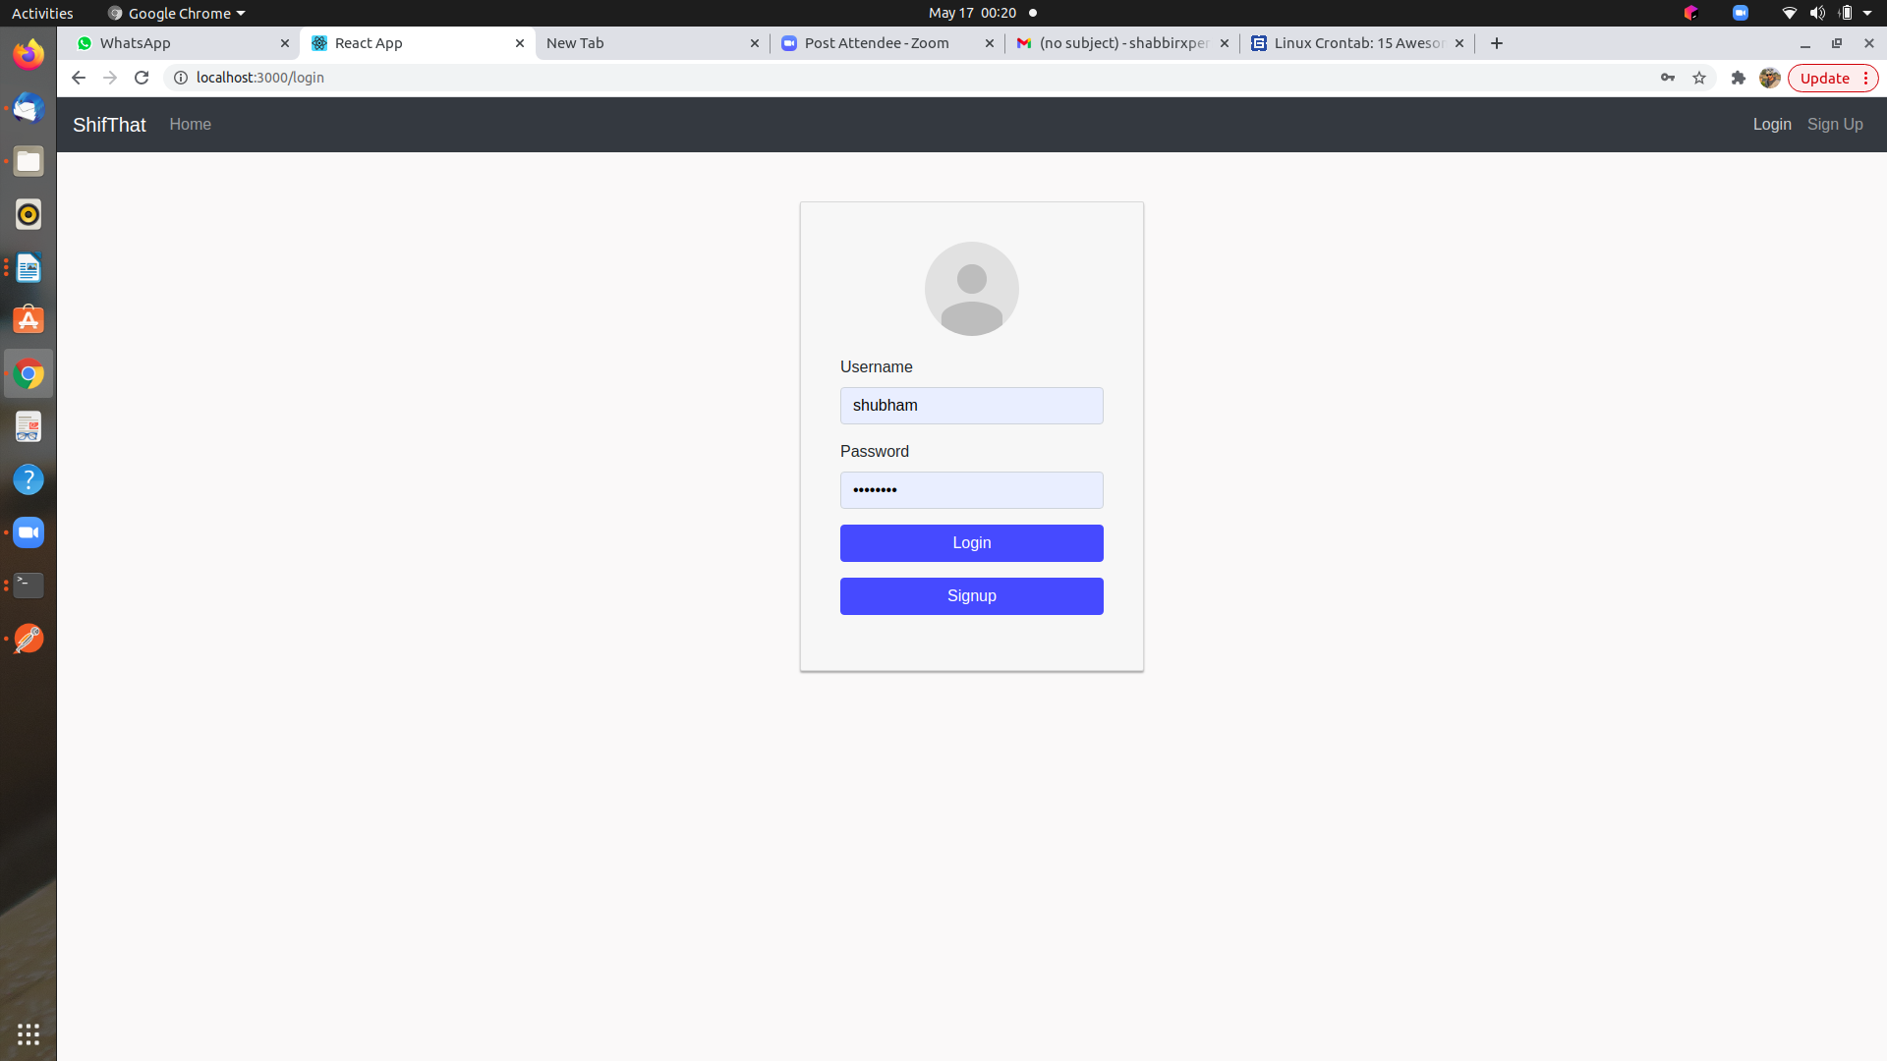

* ***Ragister page:***

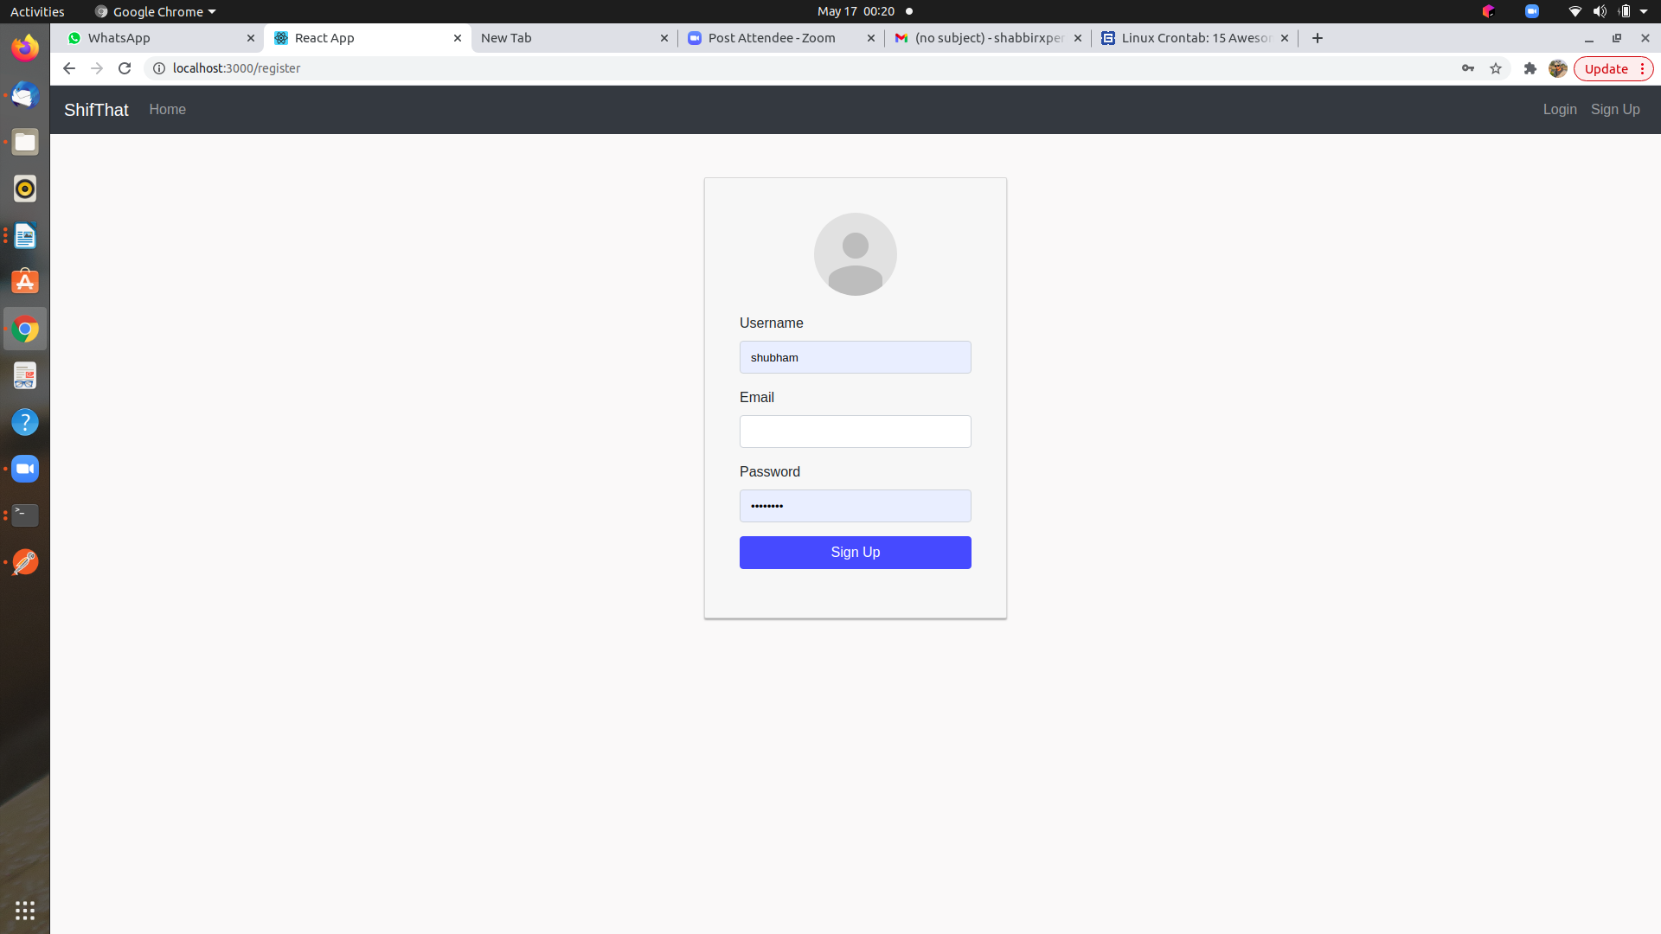

* ***Home page after login for user:***

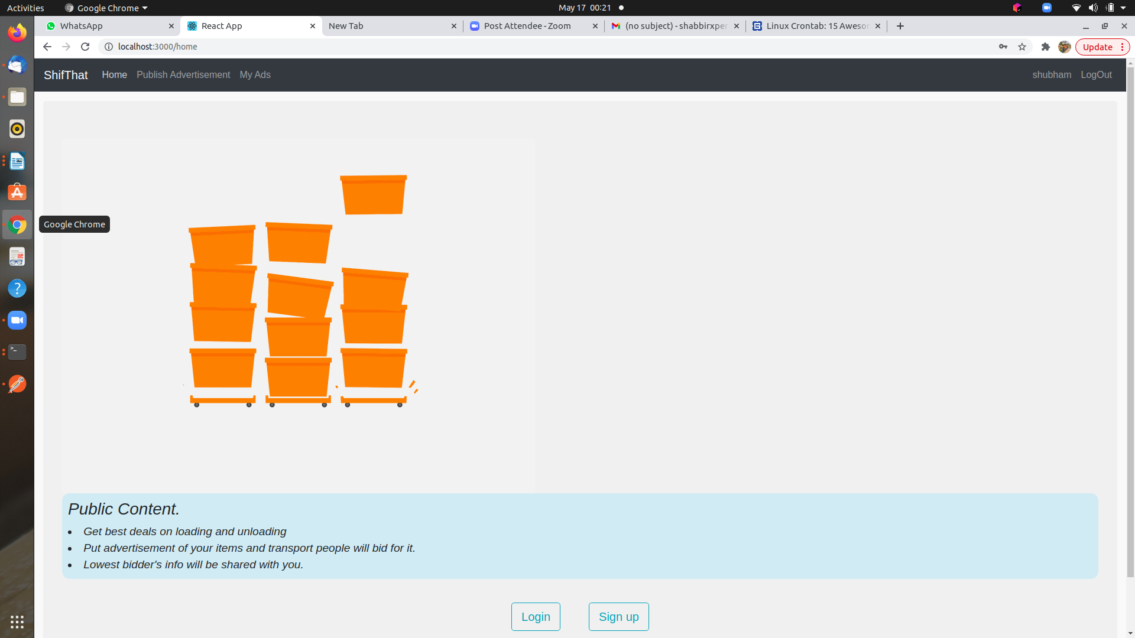

* ***User public ad from***

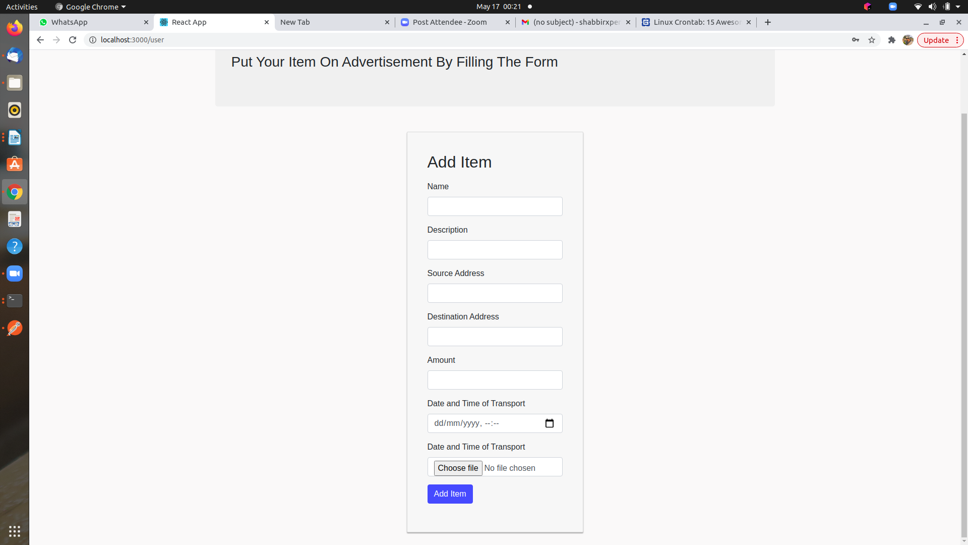

* ***User persnol detail***

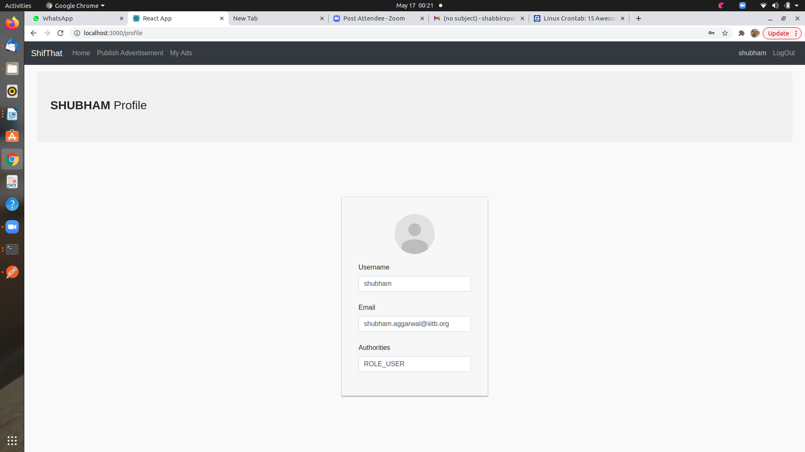

* ***Status of User item(if item are in black shads means item bid time was ended.***

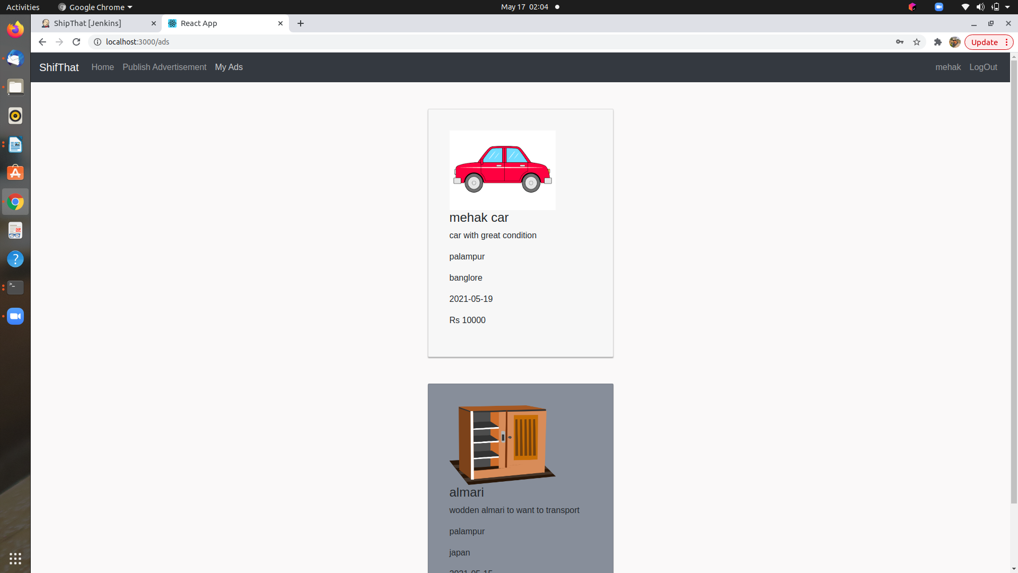

* ***Home page after login for service provider or modirator:***
* 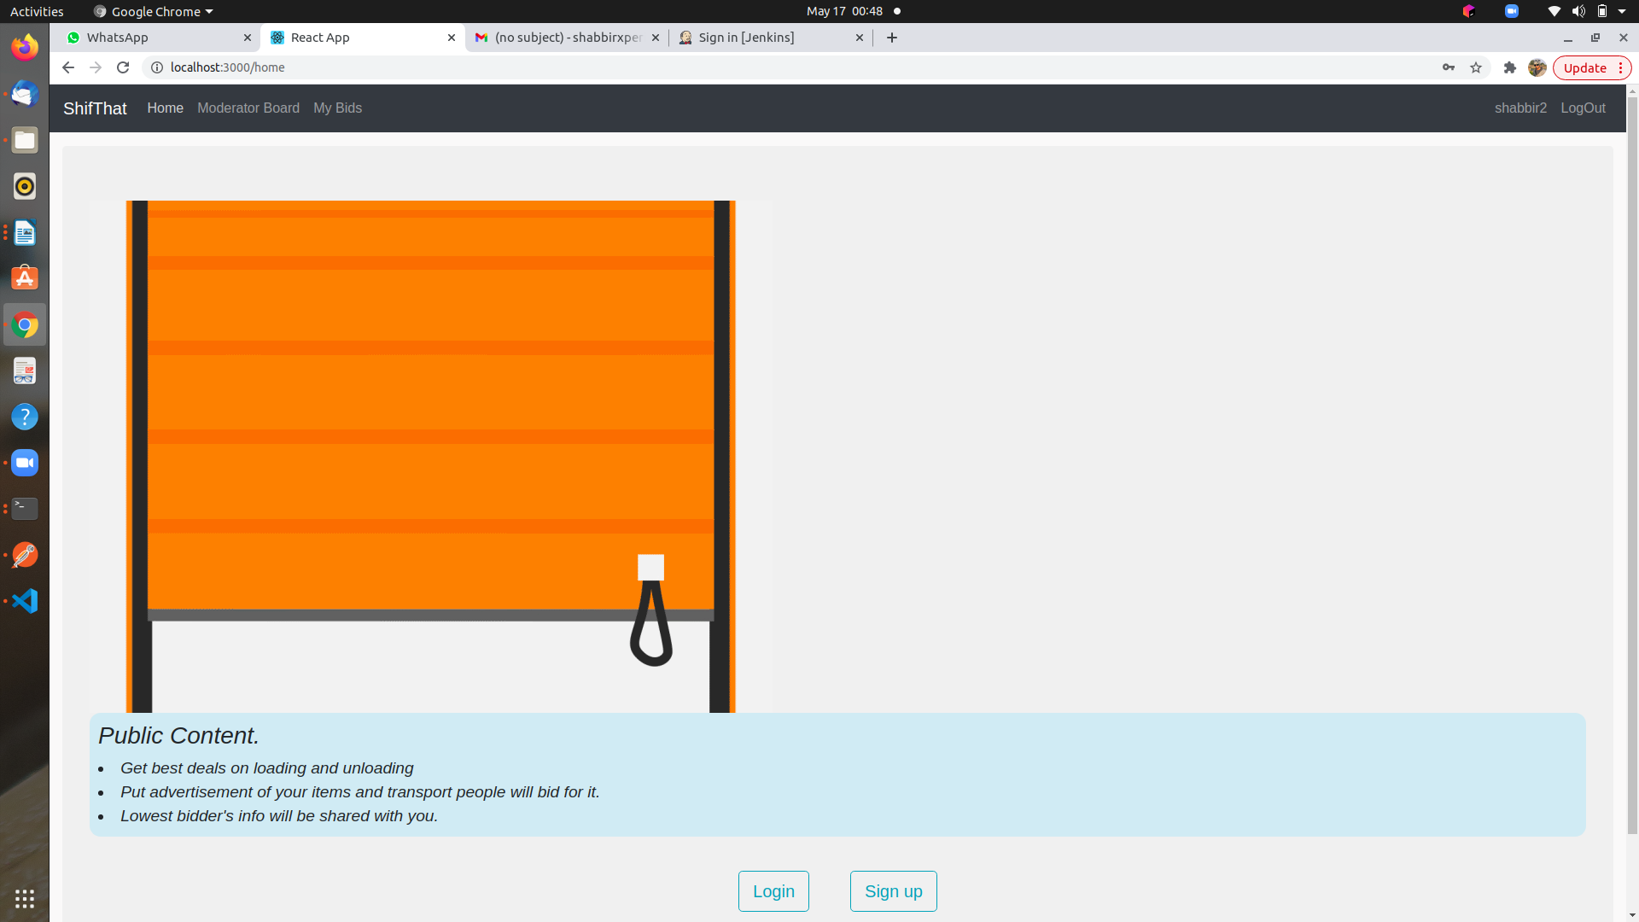***Item list on which moderater will be make bids***

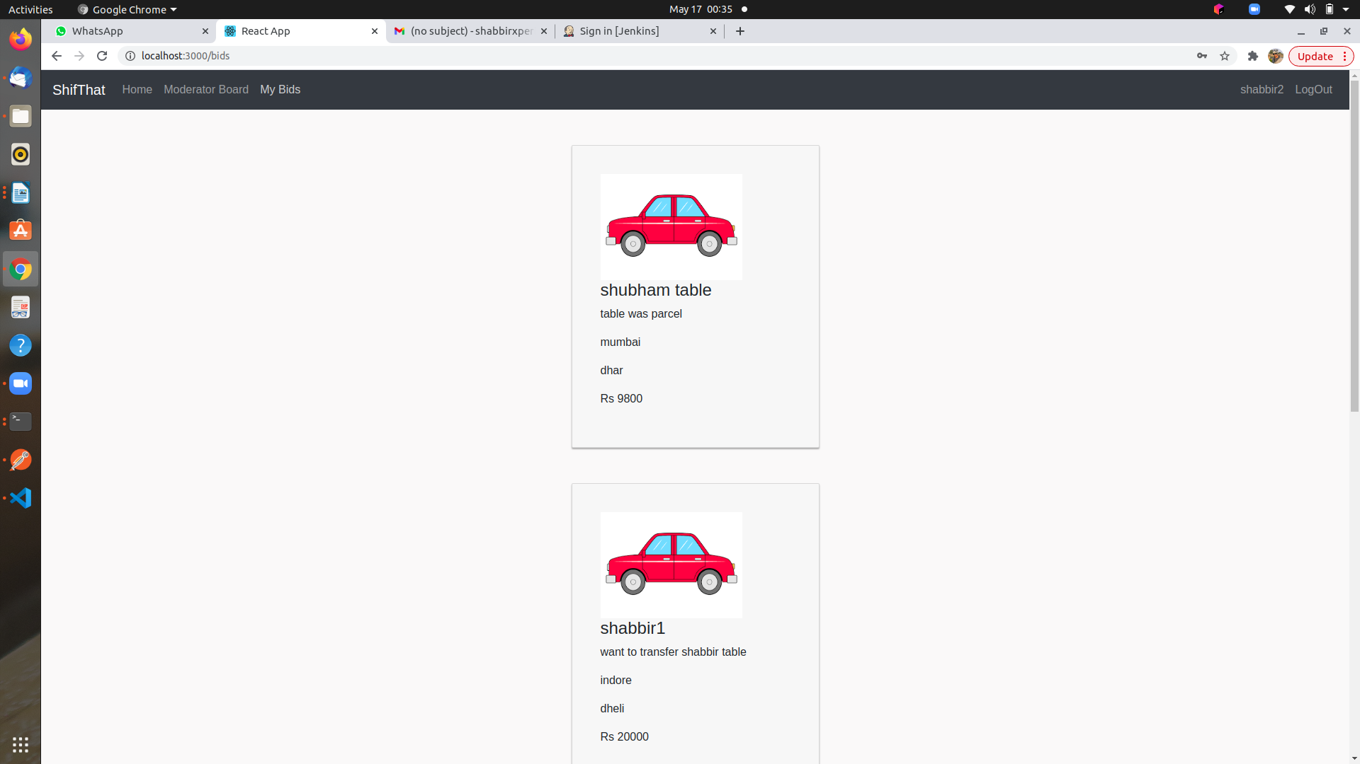

* ***Moderator Profile***

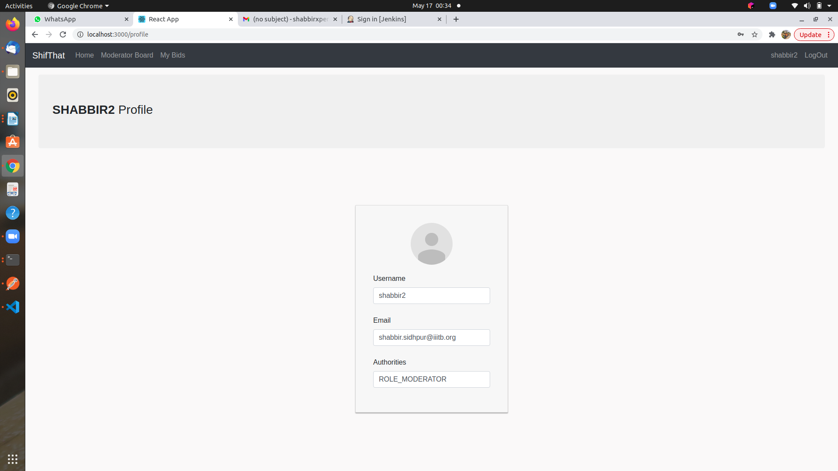

* ***Moderator have list of item for making bid if he/she are intrested in ship that item:***

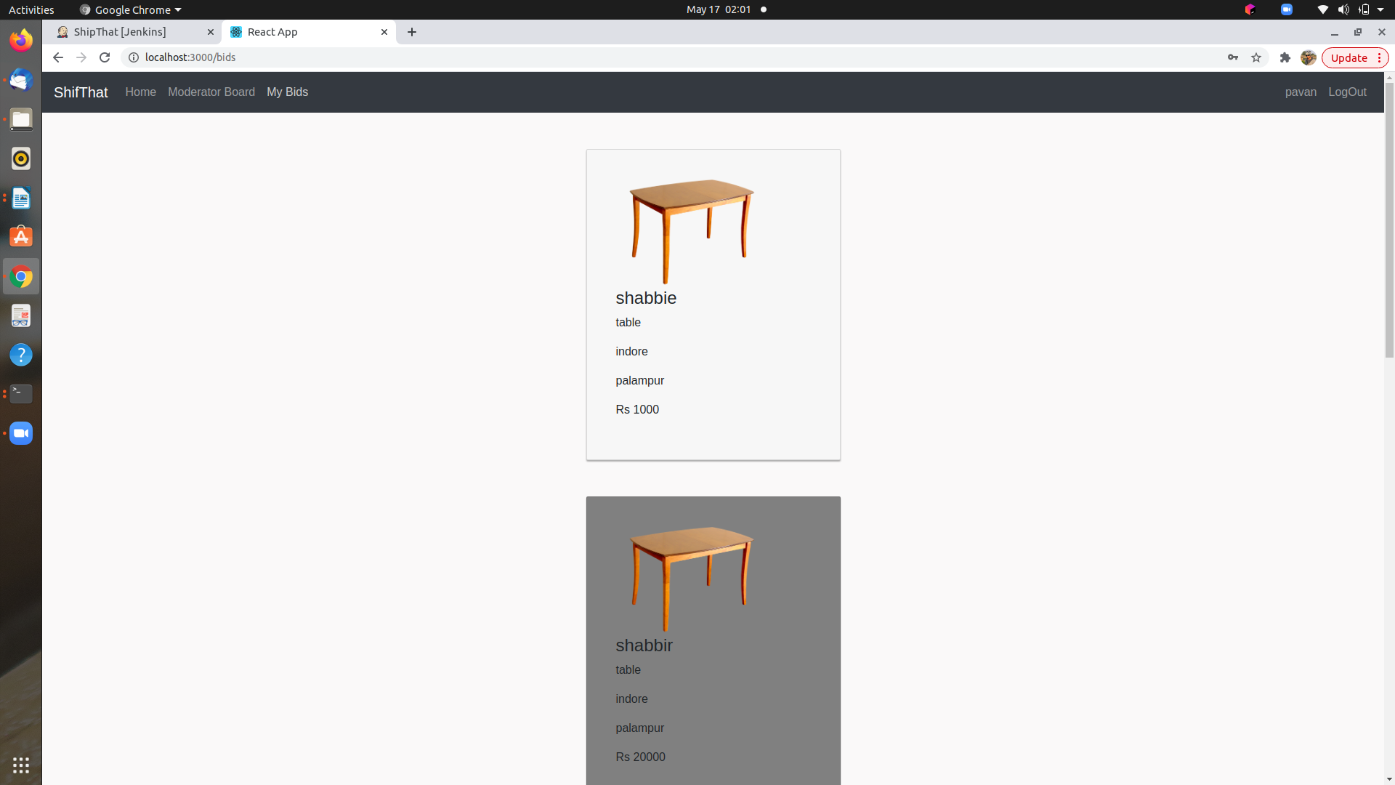

* ***Email screenshot if moderater are select for a particular item by making least bid on that.(Email will be send both party moderater which are selected and custmore which item are.)***

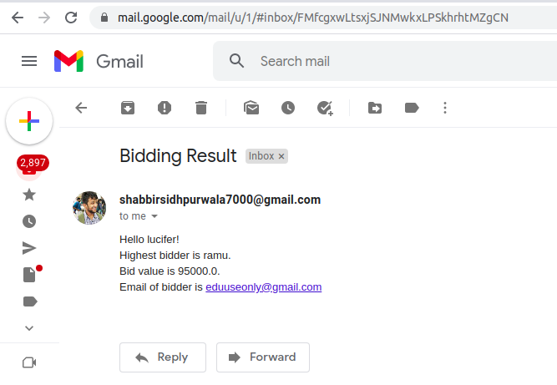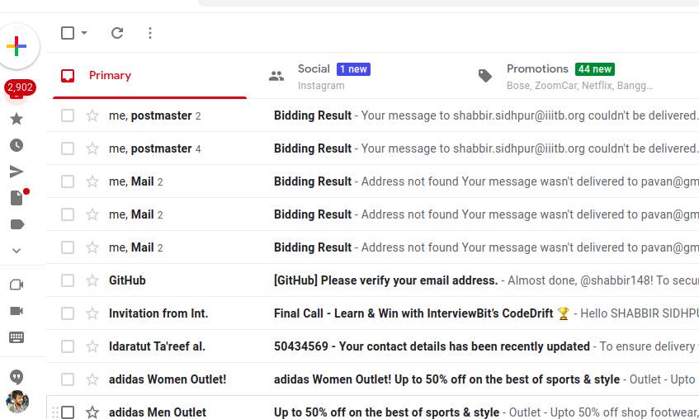

ThankYou